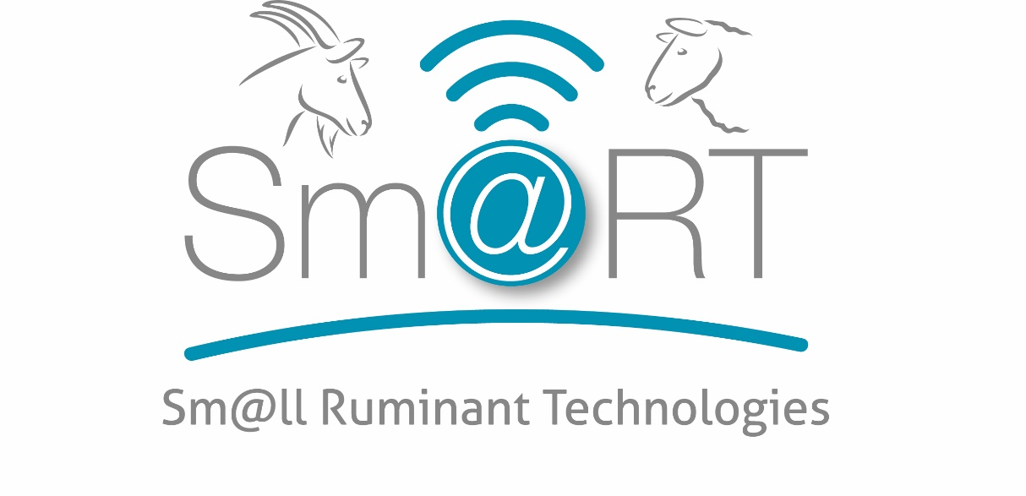
Automatic feeders
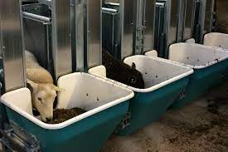
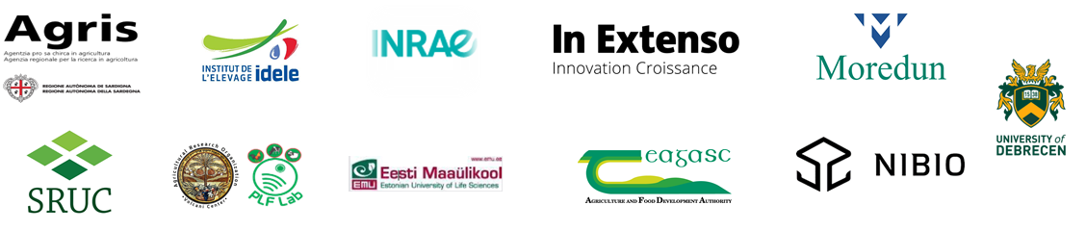
Solution name: Automatic feeders

Topic: Feeding/Health/ Welfare
Need/Challenge: Collecting individual feed intake animal data

Aim: Collecting individual feed intake animal data

Description: Sheep are identified using their ear tags. If the animal is allowed access to a specific manger the gate goes down. When the allowed access time for that period is over, the access gate goes up, pushing the animal away from the manger so that another animal can get to the gate. The weight of the manger is measured before and after animal access and the weight difference is transferred to the central computer for analysis.

How to implement: You need to have all your animals tagged. The manger is placed on a frame and rests on two electronic load cells. By turning the manger, it is easy to empty and clean it. BioControl’s PC Program extracts data of individual animal.

Expected benefits:
  - The system enables to feed animals according their individual requirements even if they share the same pen.
  - To feed different rations to different animals in the same group. The system will automatically close the gate when the animal has reached the expected intake of its ration.

Prerequisites and/or limits:
All animals need an EID tag and a PC management program is needed

Photo/video:
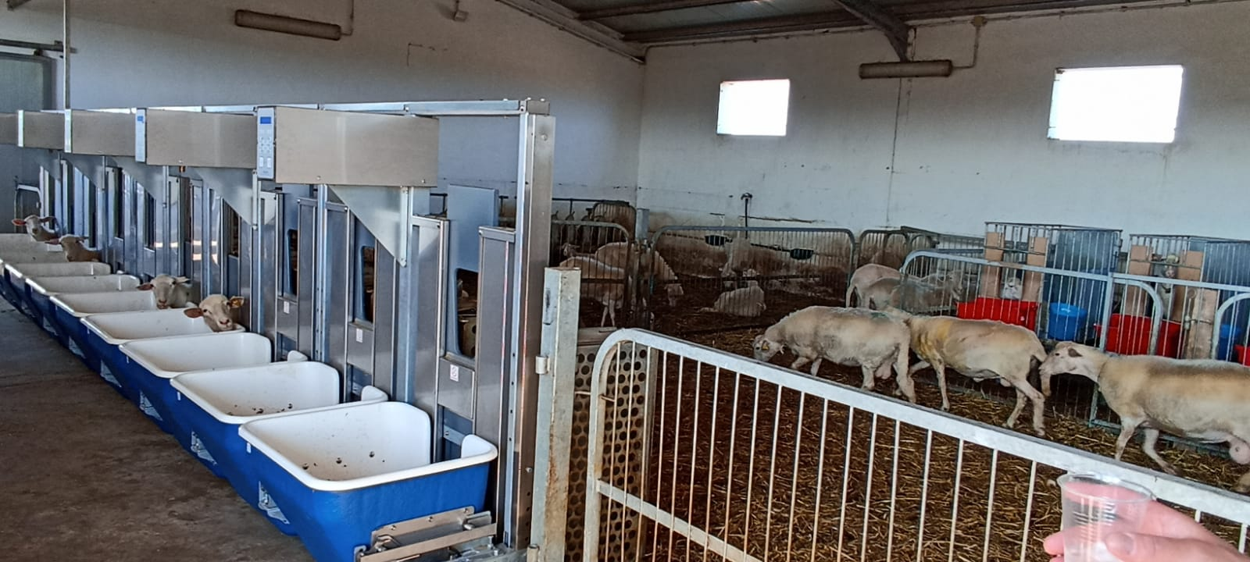

Testimonial from farmer: -
Cost-benefit-analysis: Social, environmental and welfare assessments: -

Country: Norway
Production system (Dairy or sheep/goat): Dairy sheep/goat
Category of Animal (ewe, goat, replacement, lamb, kid): ewe/goat
Source of information:

Attachment/links:
https://youtu.be/FNC1csOd6p4

