Report of the 3rd UK national workshop (NWS 3)

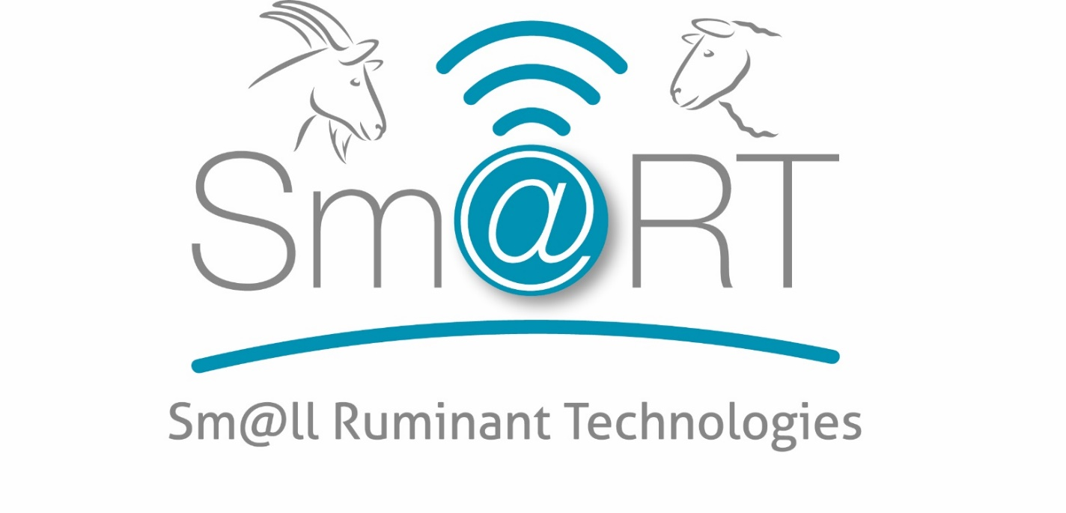
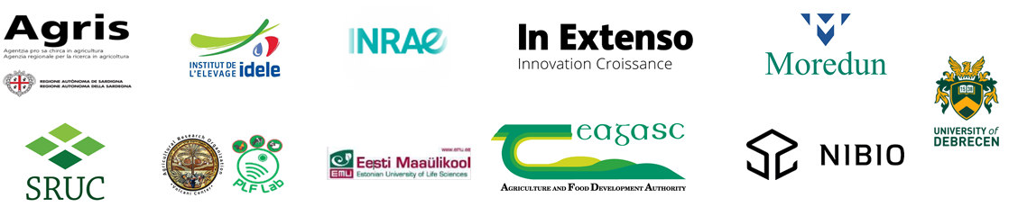

16 June 2022  Physical meeting | UK Sm@RT NWS3

Objectives

2 main objectives were identified for the third series of national workshops (NWS 3):
- Present Sm@RT project progress to stakeholders
- Get feedback on the innovative solutions tried in the prior training session

ORGANISATION AND Attendees

Due to the Covid, 2 different organisations were proposed: face-to-face meetings and virtual meetings, depending on the context of each country. For this series, the face-to-face format was encouraged. The generic agenda of the meetings is detailed in the annex 1. In the UK, the format was a face-to-face one day meeting on the Digifarm.

UK (MEAT SHEEP)

Date and place of the NWS 3: 16th June 2022, at the Hill & Mountain Research Centre, Auchtertyre farm (Digifarm UK), Crianlarich, FK20 8RU, Scotland, UK.

Present:
Number of participants: 17
Claire Morgan-Davies (SRUC, Coordinator), Ann McLaren (SRUC, NF), Ailsa Thomson (SRUC), Fiona Livingstone (SRUC), Daniel Stout (SAC Consulting), Alison Fergus (Datamars), Daye Tucker, Lawrence Martin, Dick Lewis, Gordon Murray, Peter Will, John Cameron, Kirsty Mair, Jim Strathern, Claire Strathern, Niall Campbell, John Auld.

Apologies:

Organisation:
The day was scheduled in 2 parts.
- The first part (morning) was the training day itself.
- Claire, Ann & Daniel welcomed everyone and gave an outline for the day.
- Alison Fergus gave a brief presentation on how to use the Tru-test weigh head. Then we organized the training sessions.
- Before the training session started, each participant was asked to fill in a short questionnaire about the tool they were about to try:
  - What do you think of this technology? -> smiley, neutral or grumpy
  - Would you put it on your farm? Yes or No or Neutral
- Once they had completed the session, they were asked the same questions. This was to gauge the change in their views (if any).

- The second part of the day was the workshop itself (after lunch).
- Claire presented the objectives and schedule of the afternoon. Then she presented the Sm@RT project progress and the schedule to discuss the innovative tools that were tried during the morning session.
- Before the activities in group started, each participant was asked to fill in an individual questionnaire about the 3 tools they had tried in the morning:
  - There were 10 questions for each tool:
    - 1. Did you have the tool on your farm?
    - 2. Did you like it?
    - 2. Was it easy to use?
    - 3. Would you have the infrastructure needed to implement it?
    - 4. Could you implement it on your farm easily?
    - 5. Is it affordable to you?
    - 6. Could you justify investing in it?
    - 7. Do you think it would take long to pay it back?
    - 8. Do you understand better after training?
    - 9. Would you recommend to somebody else?
    - 10. Do you think you need more training/guides/YouTube video to use it more often?

- Then the group was split in 2:
  - 1 group discussed the weigh-head/Tru-Test and autosorter
  - 1 group discussed the psion and stick reader

- Each group had to discuss the tool they were allocated and answer:
- What is the main barrier to you? Why?
- What is the main advantage to you? Why?
- Do/Would you use it for something else?
- What would you modify to implement it?

Then each group presented their findings and a general discussion ensued.

Solutions presented / tested and feedback:
Each table is the synthesis of how many farmers / stakeholders gave each answer to each question.

Name of the tool | Tru-Test weigh head
Number of answers | Smiley – Yes | Neutral | Grumpy - No
BEFORE - What do you think of this technology? | 2 | 8 | 0
BEFORE - Would you put it on your farm? | 4 | 4 | 2
AFTER - What do you think of this technology? | 7 | 2 | 0
AFTER - Would you put it on your farm? | 7 | 2 | 0
Total number of participants | 10

Name of the tool | Tru-Test weigh head
Number of answers | 1 (Not at all) | 2 (No) | 3 (Yes) | 4 (Yes a lot)
1. Did you have the tool on your farm? |  | 5 | 6
2. Did you like it? | 0 | 0 | 7 | 4
2. Was it easy to use? | 0 | 3 | 7 | 1
3. Would you have the infrastructure needed to implement it? | 0 | 3 | 7 | 1
4. Could you implement it on your farm easily? | 0 | 0 | 10 | 1
5. Is it affordable to you? | 1 | 3 | 7 | 0
6. Could you justify investing in it? | 1 | 2 | 7 | 1
7. Do you think it would take long to pay it back? | 0 | 3 | 6 | 2
8. Do you understand better after training? | 0 | 0 | 7 | 4
9. Would you recommend to somebody else? | 0 | 0 | 8 | 3
10. Do you think you need more training/guides/YouTube video to use it more often? |  | 0 | 11
Total number of participants | 11

Name of the tool | Psion
Number of answers | 1 (Not at all) | 2 (No) | 3 (Yes) | 4 (Yes a lot)
1. Did you have the tool on your farm? |  | 11 | 0
2. Did you like it? | 0 | 2 | 6 | 3
2. Was it easy to use? | 0 | 1 | 9 | 1
3. Would you have the infrastructure needed to implement it? | 0 | 1 | 10 | 0
4. Could you implement it on your farm easily? | 0 | 0 | 11 | 0
5. Is it affordable to you? | 0 | 3 | 8 | 0
6. Could you justify investing in it? | 0 | 3 | 8 | 0
7. Do you think it would take long to pay it back? | 0 | 6 | 4 | 1
8. Do you understand better after training? | 0 | 1 | 10 | 0
9. Would you recommend to somebody else? | 0 | 1 | 8 | 1
10. Do you think you need more training/guides/YouTube video to use it more often? |  | 1 | 10
Total number of participants | 11

Name of the tool | Stick reader
Number of answers | Smiley – Yes | Neutral | Grumpy - No
BEFORE - What do you think of this technology? | 4 | 5 | 1
BEFORE - Would you put it on your farm? | 4 | 4 | 2
AFTER - What do you think of this technology? | 9 | 1 | 0
AFTER - Would you put it on your farm? | 7 | 2 | 1
Total number of participants | 10

Name of the tool | Stick reader
Number of answers | 1 (Not at all) | 2 (No) | 3 (Yes) | 4 (Yes a lot)
1. Did you have the tool on your farm? |  | 3 | 8
2. Did you like it? | 0 | 3 | 5 | 3
2. Was it easy to use? | 0 | 1 | 8 | 2
3. Would you have the infrastructure needed to implement it? | 0 | 1 | 8 | 2
4. Could you implement it on your farm easily? | 0 | 1 | 8 | 2
5. Is it affordable to you? | 0 | 1 | 7 | 2
6. Could you justify investing in it? | 0 | 2 | 5 | 3
7. Do you think it would take long to pay it back? | 2 | 3 | 6 | 0
8. Do you understand better after training? | 0 | 0 | 8 | 3
9. Would you recommend to somebody else? | 0 | 4 | 4 | 2
10. Do you think you need more training/guides/YouTube video to use it more often? |  | 3 | 7
Total number of participants | 11
Answers to the group discussions:

Main barrier to you? Why?

EID Weigh Crate
- Cost
- Abilities- Confidence
- Need for additional software
- Computer system
- Mobile? Grazing spread out
- Needs time for training/support
- Age
- Time
Handhelds
- Psion ++
- Stick- basic
- Easier to understand
- Portable

Main advantage to you? Why?

EID Weigh Crate
- Efficiency
- Accuracy
- Health- eg. Early alert
- Knowledge
- Time
Handhelds
- Psion- more info and capabilities
- Stick reader- links well with apps

Bigger picture
- Information hub/support- relationship with supplier (try before you buy)
- Skill matching
- Education/Training academies (e.g. videos, tutorials, etc)
- Face to face
- Mentor
- Support-personal
- Feedback process
- Price/Grants
- Adapt to system/Bespoke
- Portability
- Compatibility
- Simplify
- Flexibilities

Tru- Test & Scales

Barrier?
- Cost
- Mobile/Weight
- Needs electricity
- Need training
- Compatibility to handling systems and tech

Advantage?
- Automatic (Autodraft)
- Easy
- Reduce labour
- Record lots of traits
Modify?
- Animal could be more accessible for treatments- Combi Clamp solution
- More analysis and summaries
- More transportable

Stick Reader

Barrier?
- Fear of tech
- Cost
- Compatibility
- Transfer
- Awareness
- No experience
- Lack of training/support

Advantage?
- Paperless
- Easier- movements
- Compliance/ farm assurance
- Individual animal ID in future
Use it for something else?
- Cattle if compatible
Modify?
- Clunky pad
Psion

Barrier?
- As before
- Cost
- More complicated than may be required- link to movements
Advantage?
- Historic Data
- Lambing traits
- Add additional traits
- Link to movements
- Medicines- easier compliance
Use it for something else?
- All stock
Modify?
- Modify screen selection to only traits used
- App link
- 4G
- Smaller

Annexes

Annex 1 - AGENDA
- Workshop objective:
  - Objective: to get feedback on the innovative solutions tried in the morning training session
  - Target: Farmers, advisers, consultants, technicians, innovative farms.

- Workshop:
- Between 2 to 3 hours
- Inside (or in a shed) with PPT projector, and enough space to have small discussion groups (with social distancing if necessary).
- Food and coffee/tea (depending on the format)
- We need ~10- 15 people per production type. If you consider more than one production, then it may be easier to organise workshops in parallel or several workshops.

Workshop contents proposition:
Section | Timing | Objective of the section | Content – what are the participants doing | Who does what? | Material/props needed
Welcome | 20’  (20’) | Reminder of the previous meeting (NWS + TNWS)  Objectives for the afternoon | Introduction, rules of engagement, health & safety rules, objectives, quick agenda.  What do you remember from the last sessions? | NF  NF or other colleague | PPT or oral
Feedback on the solutions/tools tried in the morning | 50’  (70’) | Feedback on the tools (with barriers) | 3 parts:  - Individual questionnaire to fill in (~10 min – maybe longer)  - Group discussion:  Put the participants in small groups with flip chart  - Each group to consider 1 or 2 tool (and answer a series of questions) (~15 min each)  - Rotate the groups so that each group has considered all the tools  - Feedback to the whole group:  For each tool – each group presents their findings and add to the other groups findings (pin on the chart?) | NF + colleagues (1 person per group?) | Individual questionnaire to print  Flip chart with open questions  Paper boards in colour to write their answers (and pin to the flip chart)  OR POST-ITS
Conclusion | 10’  (80’) | Next steps and how we value their input.  Dates | Reminder of the website + social media  Next steps – TNWS, etc.  Use of paperboard for feedback:  2 questions with 3 smileys each :  - Did you enjoy the meeting and discussions?  - How was the meeting organisation? | NF | PPT  Paper board  pens

Individual questionnaire: (to adapt based on the tools you will showcase in the morning) -
Please tick your answer | 1 (Not at all) | 2 (No) | 3 (Yes) | 4 (Yes a lot)
1. Did you have the tool on your farm?
2. Did you like it?
2. Was it easy to use?
3. Would you have the infrastructure needed to implement it?
4. Could you implement it on your farm easily?
5. Is it affordable to you?
6. Could you justify investing in it?
7. Do you think it would take long to pay it back?
8. Do you understand better after training?
9. Would you recommend to somebody else?
10. Do you think you need more training/guides/YouTube video to use it more often?

Questions for the group discussion: THESE ARE THE FINALISED QUESTIONS
- What is the main barrier to you?
Why?
- What is main advantage to you?
Why?
- Do/Would you use it for something else?
- What would you modify to implement it?

NWS3 – Questions for the morning session (training itself)

Before the training start:
For each tool showcased:
What do you think of this technology? -> smiley, neutral or grumpy
Would you put it on your farm? Yes or No or Neutral
Collect their sheets (with names on it)
After the training:
Give them their sheets back and ask people to answer the same 2 questions.

Filming at lunchtime (for those who agree): (feedback) – ask them the 3 questions and record their answers
Preferably in front of the Sm@RT pull-up or poster.
- What is your farm type (sheep/goats/dairy/hill/upland/lowland)
- How many sheep or goats
- What do you think of the techs you have just used during the training?

Annex 2- Sign in sheets
