Report of the 4th UK national workshop (NWS 4)

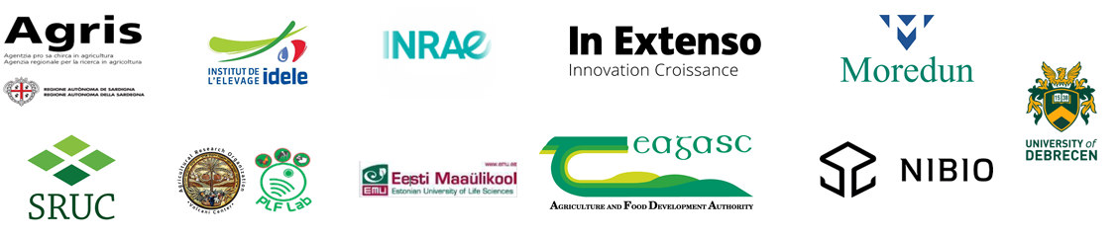
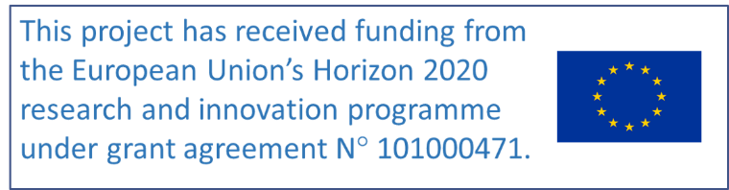

22 May 2023  Physical meeting | UK Sm@RT NWS4

Objectives

3 main objectives were identified for the fourth series of national workshops (NWS 4):
- Present Sm@RT project progress to stakeholders
- Present summary of New Zealand visit
- Carry out a workshop on adoption of technologies

ORGANISATION AND Attendees

Due to Covid, 2 different organisations were proposed: face-to-face meetings and virtual meetings, depending on the context of each country. For this series, the face-to-face format was encouraged. The generic agenda of the meetings is detailed in the annex 1. In the UK, the format was a face-to-face one day meeting at Carbeth Home Farm.

UK (MEAT SHEEP)

Date and place of the NWS 4: 22nd May 2023, at Carbeth home Farm, Near Balfron, Stirlingshire.

Present:
Number of participants: 26
Claire Morgan-Davies (SRUC, Coordinator), Ann McLaren (SRUC, NF), Fiona Kenyon (MRI), Daniel Stout (SAC Consulting), Jack Munro (SAC Consulting), Ailsa Thomson (SRUC), Michelle Reeves (SRUC), Aimee Walker (SRUC), Eilidh Geddes (MRI), Lawrence Martin (farm host), Daye Tucker (farm host – note missed the signing sheet), Frank Turnbull (FecPak), Christine Cuthbertson (Quality Meat Scotland), Michael Holmes, Dawn Holmes, Fergus Younger, Gordon Murray, James MacDougall, Bobby Lenox, Kirsty Mair, Cameron McCooey, Jack Cuthbert, Catherine Pringle, Janet Beveridge, Shona Duncan, Rebecca Duncan.

Apologies:

Organisation:
The day was scheduled in 2 parts.
- The first part (morning) included on-farm demos of technology.
- Claire, Ann, Daniel & Fiona welcomed everyone and gave an outline for the day.
- Before the demos started, each participant was asked to fill in a short questionnaire about the tool that was about to be shown:
  - Do you have the tool? -> Yes or No
  - Do you think it is worth investing in it? -> Yes or No
  - Would you like to implement it on your farm? -> Yes or No
  - Level of practicality (1 to 5)
- Once the demo was completed, they were asked the same questions. This was to gauge the change in their views (if any).
- Participants then split into smaller groups and listened to several presentations on different technologies, including proximity sensors/Bluetooth beacons and FEC Pack.

- The second part of the day was the interactive workshop (after lunch).
- Claire, Ann and Fiona presented the New Zealand visit.
- Claire presented the objectives and schedule of the afternoon.
- The group was split into 3 groups, each chose a technology to discuss in the technology adoption session.
- Each group discussed their chosen technology and answered the following questions (using a multiple choice scale):
- What proportion of the target population has maximising profit as a strong motivation?
- What proportion of the target population has protecting the natural environment as a strong motivation?
- What proportion of the target population has risk minimisation as a strong motivation?
- On what proportion of the target farms is there a major enterprise that could benefit from the innovation?
- What proportion of the target population has a long-term (greater than 10 years) management horizon for their farm?
- What proportion of the target population is under conditions of severe short-term financial constraints?
- How easily can the innovation (or significant components of it) be trialled on a limited basis before a decision is made to adopt it on a larger scale?
- Does the complexity of the innovation allow the effects of its use to be easily evaluated when it is used?
- To what extent would the innovation be observable to farmers who are yet to adopt it when it is used in their district?
- What proportion of the target population uses paid advisors capable of providing advice relevant to the project?
- What proportion of the target population participates in farmer-based groups that discuss farming?
- What proportion of the target population will need to develop substantial new skills and knowledge to use the innovation?
- What proportion of the target population would be aware of the use or trialling of the innovation in their district?
- What is the size of the up-front cost of the investment relative to the potential annual benefit from using the innovation?
- To what extent is the adoption of the innovation able to be reversed?
- To what extent is the use of the innovation likely to affect the profitability of the farm business in the years that it is used?
- To what extent is the use of the innovation likely to have additional effects on the future profitability of the farm business?
- How long after the innovation is first adopted would it take for effects on future profitability to be realised?
- To what extent would the use of the innovation have net environmental benefits or costs?
- How long after the innovation is first adopted would it take for the expected environmental benefits or costs to be realised?
- To what extent would the use of the innovation affect the net exposure of the farm business to risk?
- To what extent would the use of the innovation affect the ease and convenience of the management of the farm in the years that it is used?
- Each group then put their answers into the ADOPT software.

Solutions presented and feedback:
Each table is the synthesis of how many farmers / stakeholders gave each answer to each question.

Name of the tool | Farm Management Software
Number of answers | Yes |  |  | No
BEFORE – Do you have the tool? | 3 |  |  | 10
BEFORE – Do you think it is worth investing? | 11 |  |  | 2
BEFORE - Would you put it on your farm? | 11 |  |  | 2
AFTER – Do you think it is worth investing? | 12 |  |  | 1
AFTER - Would you put it on your farm? | 12 |  |  | 1
Level of Practicality | 1 | 2 | 3 |  | 4 | 5
BEFORE | 0 | 0 | 7 |  | 2 | 2
AFTER | 0 | 0 | 3 |  | 5 | 4
Total number of participants | 13

Name of the tool | Combi Clamp with weigh head
Number of answers | Yes |  |  | No
BEFORE – Do you have the tool? | 8 |  |  | 5
BEFORE – Do you think it is worth investing? | 13 |  |  | 0
BEFORE - Would you put it on your farm? | 13 |  |  | 0
AFTER – Do you think it is worth investing? | 12 |  |  | 1
AFTER - Would you put it on your farm? | 11 |  |  | 2
Level of Practicality | 1 | 2 | 3 |  | 4 | 5
BEFORE | 0 | 0 | 3 |  | 3 | 6
AFTER | 0 | 0 | 2 |  | 6 | 3
Total number of participants | 13

Answers to the Technology adoption session:
Two of the three groups were made up predominantly of farmers, plus an advisor. The third group was mostly researchers and other stakeholders.
The tools covered in the ADOPT sessions were:
- EID-enabled stick reader (farmer & advisor group)
- Farm management software (farmer & advisor group)
- Virtual fence (researchers & other stakeholder group)

Based on the answers given by each group to the 22 questions detailed above, the ADOPT software generates a series of outputs relating to adoption levels and highlights which questions were the most sensitive to any changes made to the answer given.

A brief summary of the results from the different groups are given below:

EID-enabled stick reader Farm management software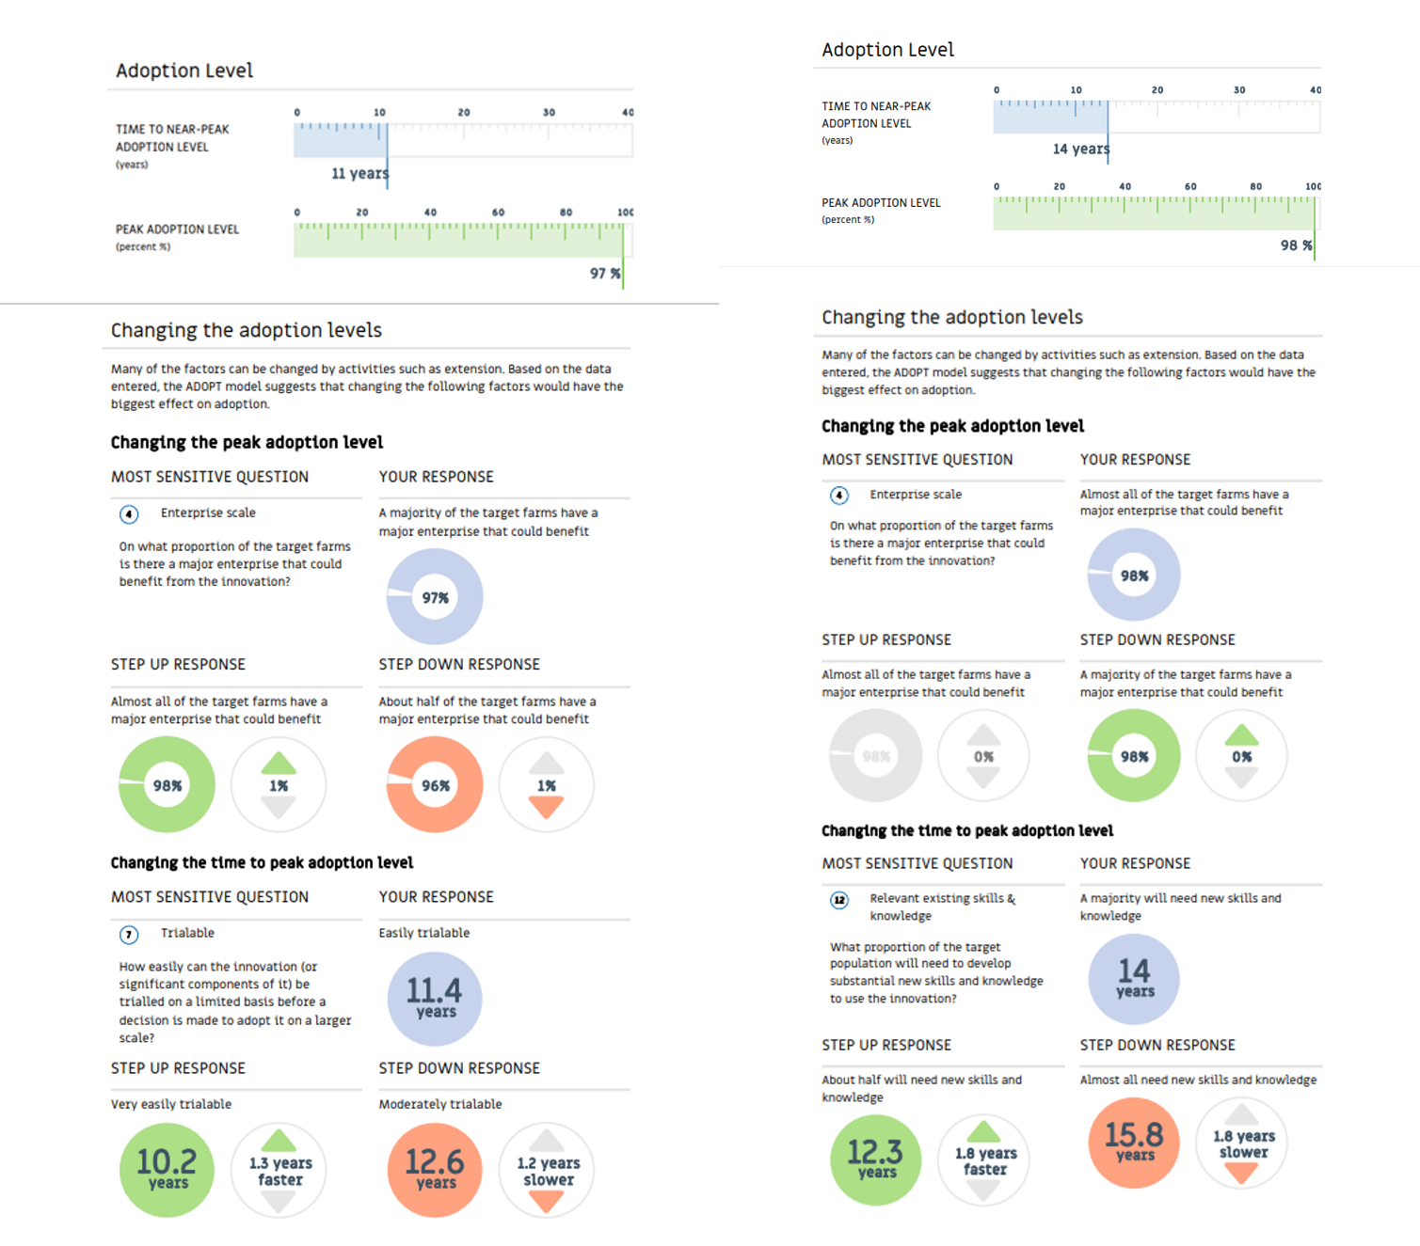
Virtual Fence
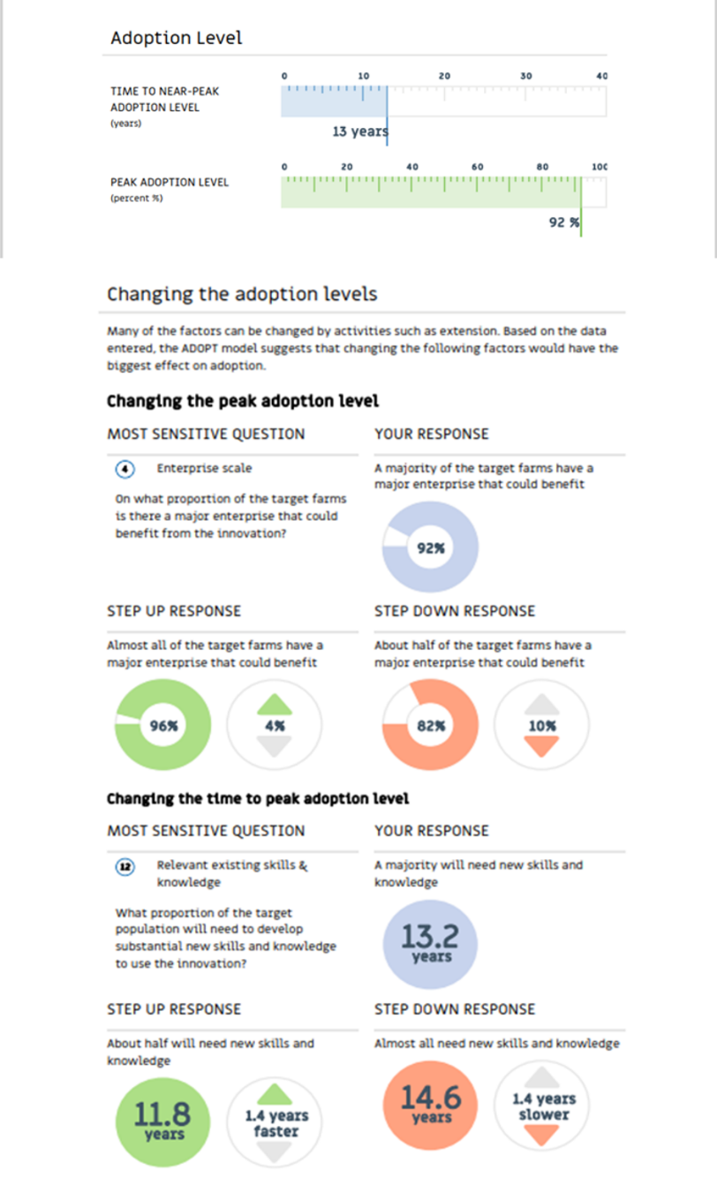

Annexes

Annex 1 - AGENDA
- Workshop objective:
  - Objective: to share about technologies seen in New-Zealand and get feedback on the adoption of solutions listed before in the project
  - Target: Farmers, advisers, consultants, technicians, innovative farms.

- Workshop:
- Between 2 to 3 hours
- Inside (or in a shed) with PPT projector, and enough space to have small discussion groups (with social distancing if necessary).
- Food and coffee/tea (depending on the format)
- We need ~10- 15 people per production type. If you consider more than one production, then it may be easier to organise workshops in parallel or several workshops.

Workshop contents proposition:
Section | Timing | Objective of the section | Content – what are the participants doing | Who does what? | Material/props needed
Welcome and project progress | 30’  (30’) | Reminder of the previous meeting (NWS + TNWS)  Objectives for the afternoon | Introduction, rules of engagement, health & safety rules, objectives, quick agenda.  What do you remember from the last sessions? | NF  NF or other colleague | PPT or oral
Feedback on the solutions seen in New-Zealand | 60’  (90’) | Feedback on the New-Zealand tools and farms | Presentation of the trip, the farms and the tools  Discussion:  - What do you think about it?  - Did some technologies interest you? | NF | PPT
ADOPT | 75’  (165’) | Estimation of the adoption level of one or more technologies | Select 1 or more tools, and in small groups of 3 – 5 people, fill the ADOPT questionnaire.  Use mentimeter for the group to answer. | NF + one or more colleague | PPT  Mentimeter
Conclusion | 15’  (180’) | Next steps and how we value their input.  Dates | Reminder of the website + social media  Next steps – TNWS, etc.  Use of paperboard for feedback:  2 questions with 3 smileys each :  - Did you enjoy the meeting and discussions?  - How was the meeting organisation? | NF | PPT  Paper board  pens

Individual questionnaire: (to adapt based on the tools you will showcase in the morning) -
BEFORE THE DEMONSTRATION | Yes | No
Do you have the tool?
Do you think it is worth investing in it?
Would you like to implement on your farm?
 |  | 1 | 2 | 3 | 4 | 5
Level of practicality (1=low, 5=high)

AFTER THE DEMONSTRATION | Yes | No
Do you think it is worth investing in it?

Would you like to implement on your farm?
 |  | 1 | 2 | 3 | 4 | 5
Level of practicality (1=low, 5=high)

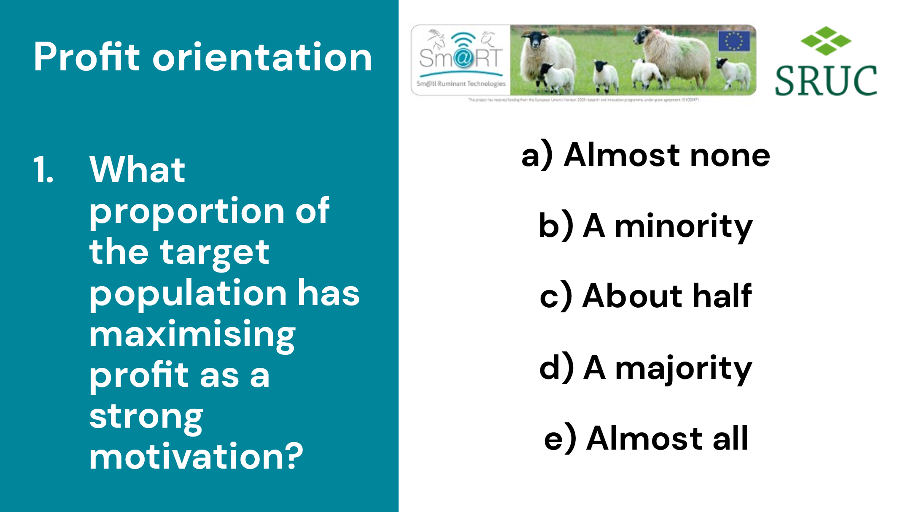
Questions for the group discussion:
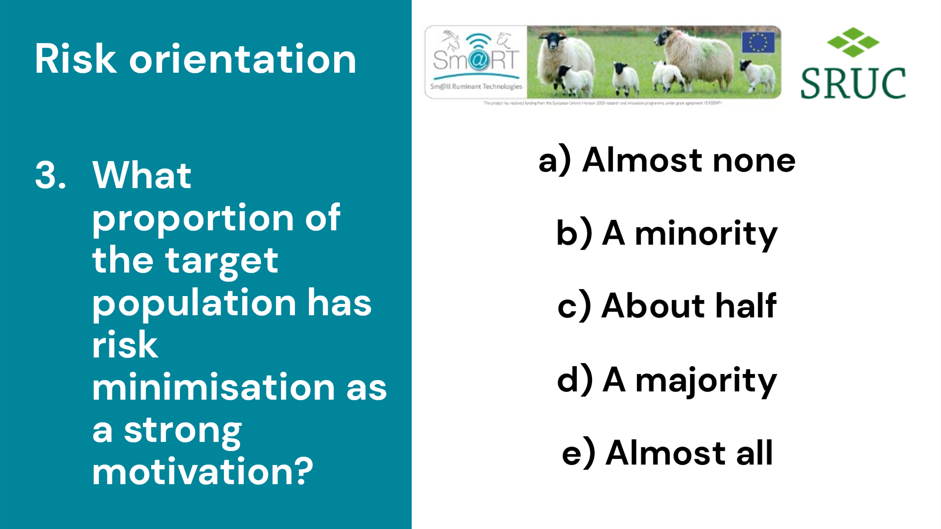
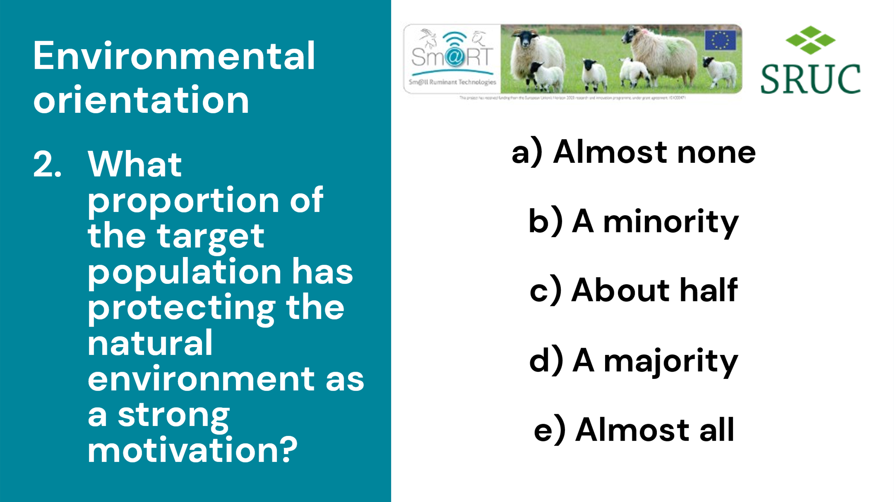
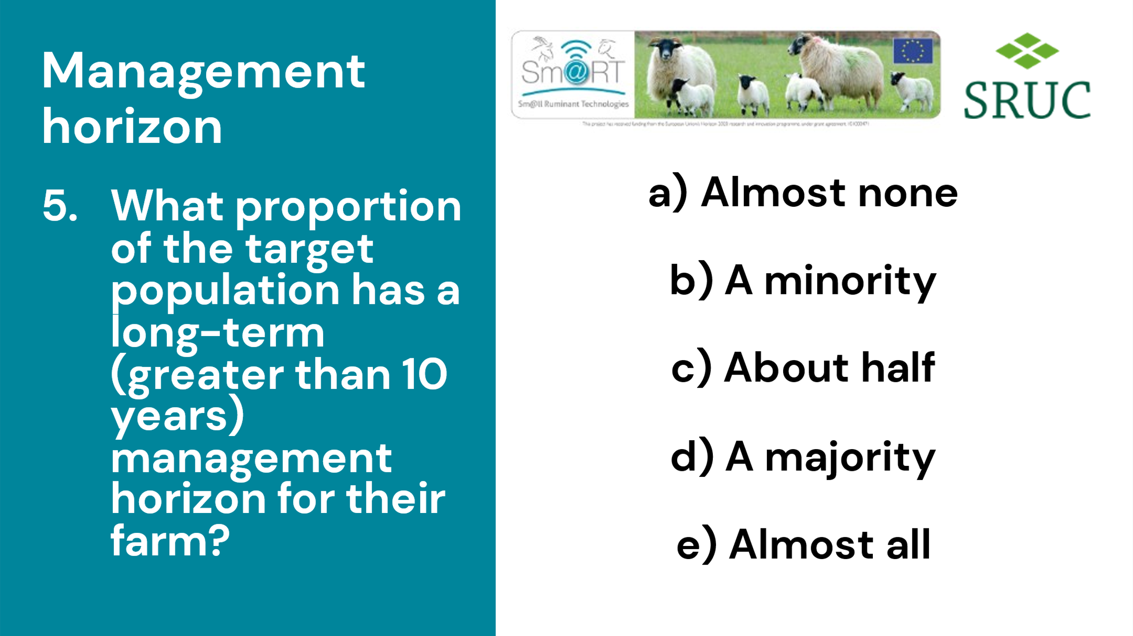
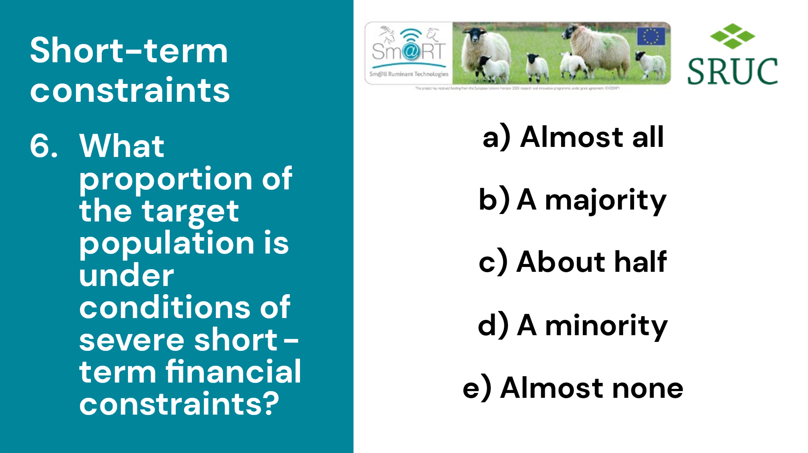
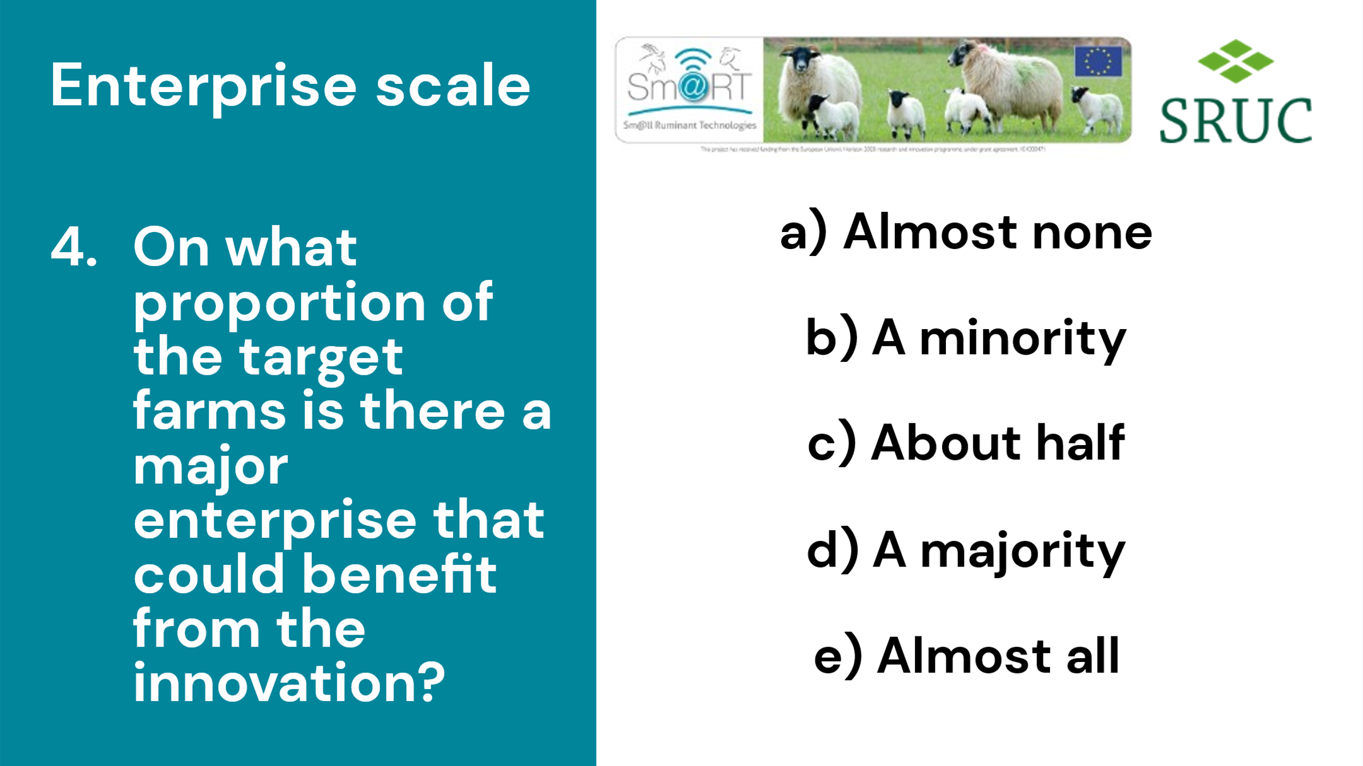

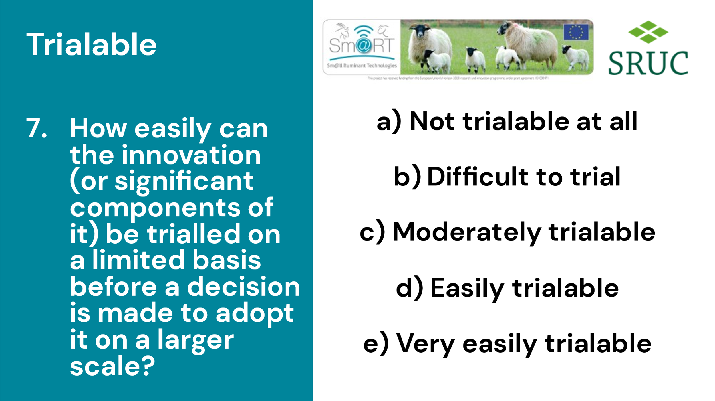

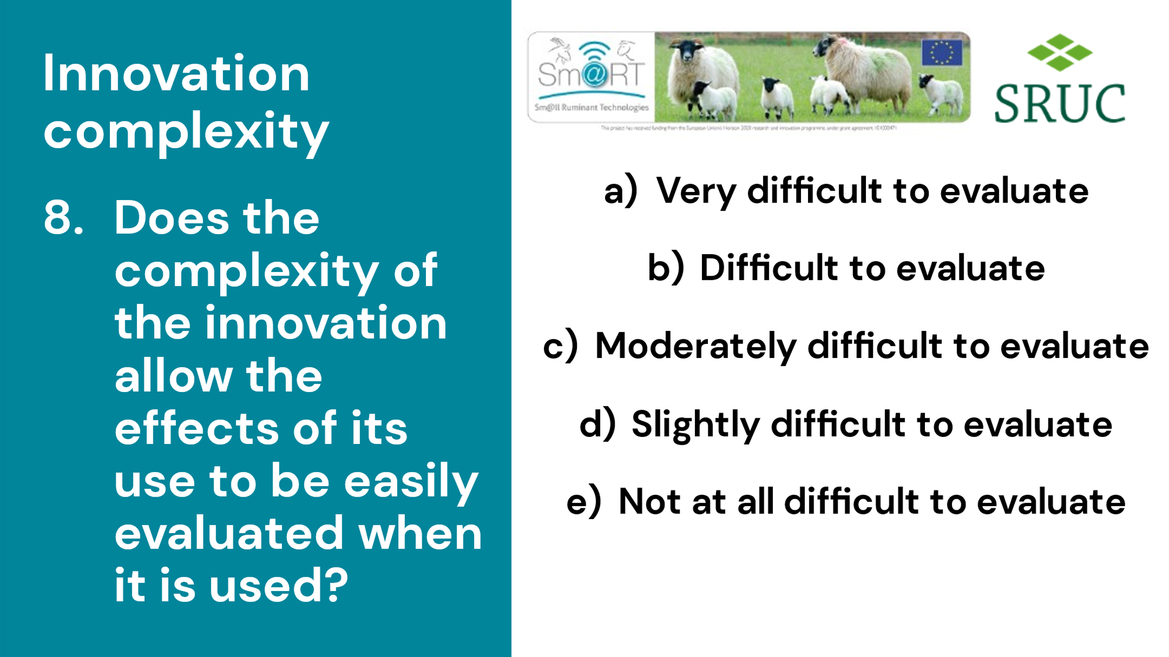

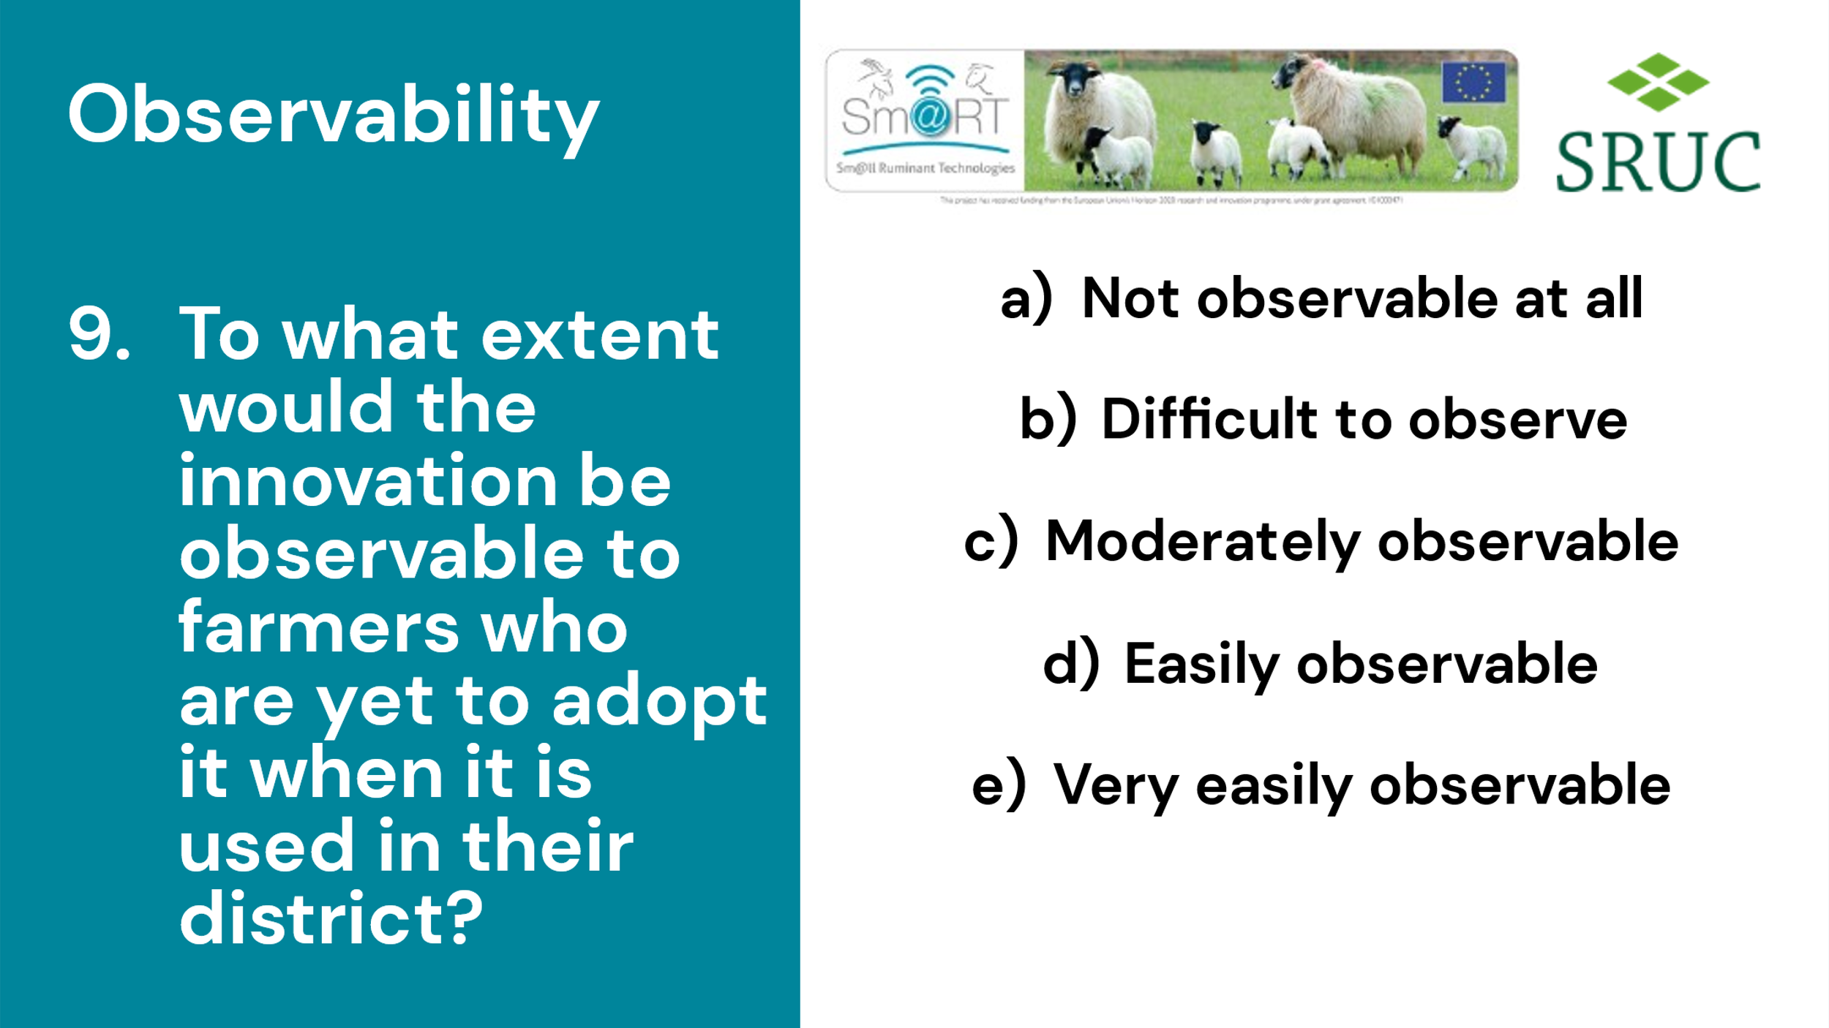

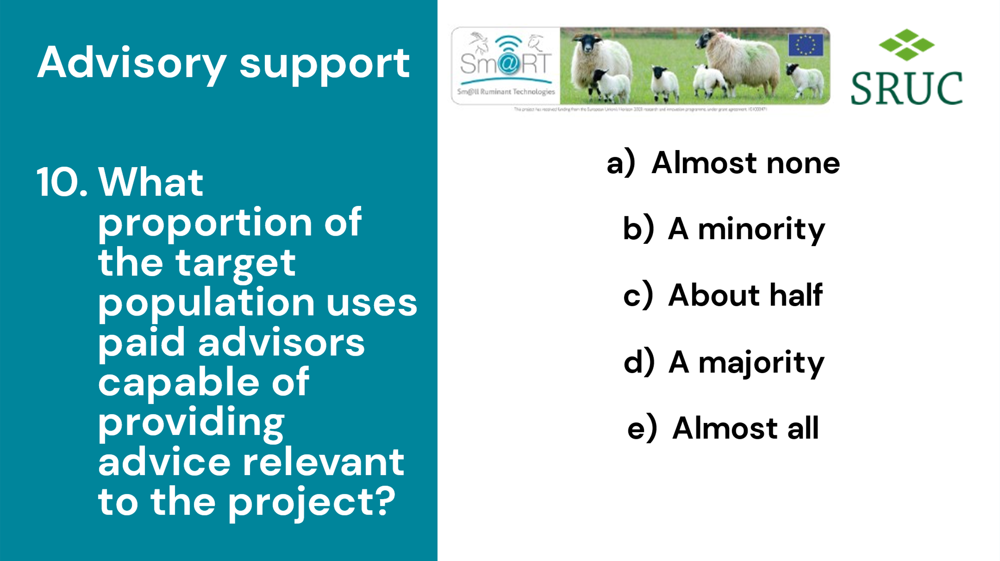

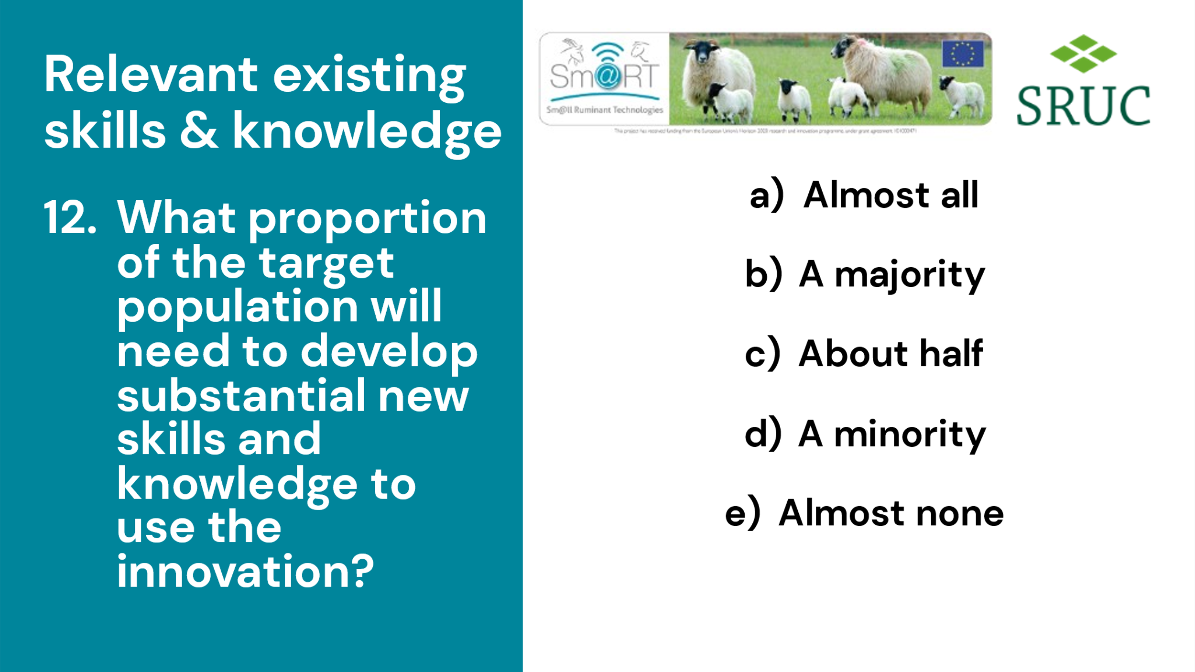
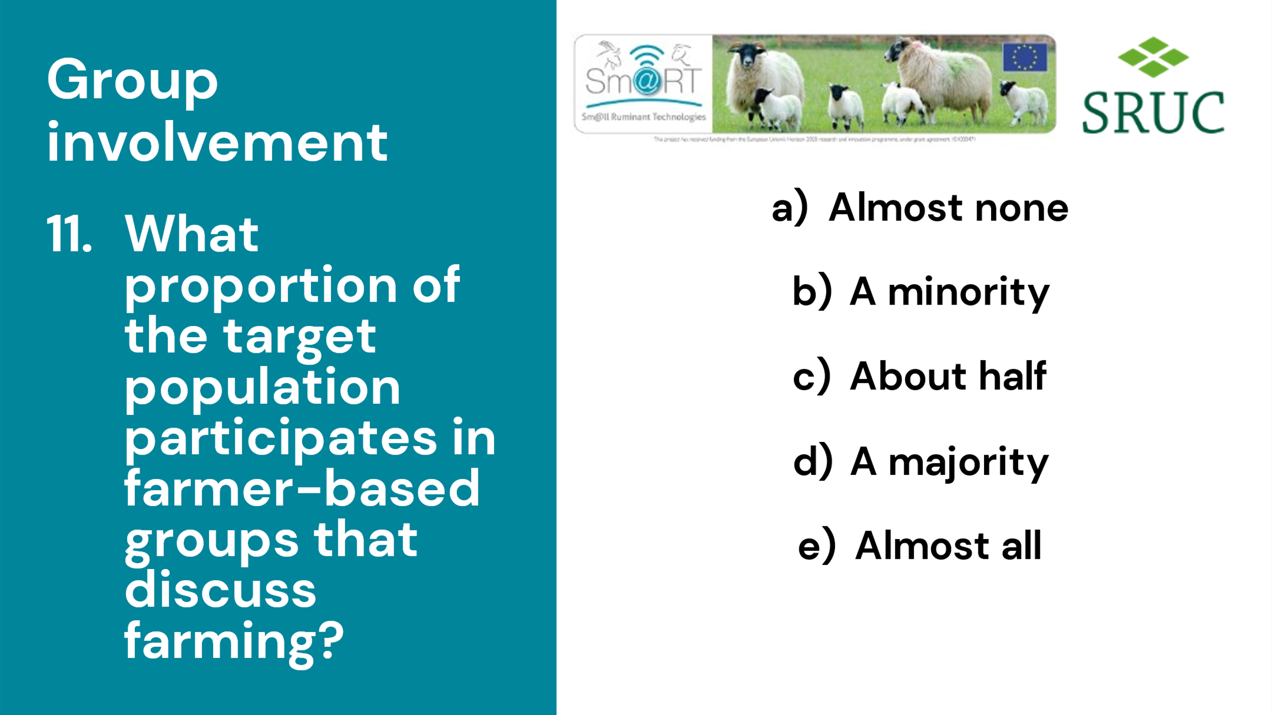

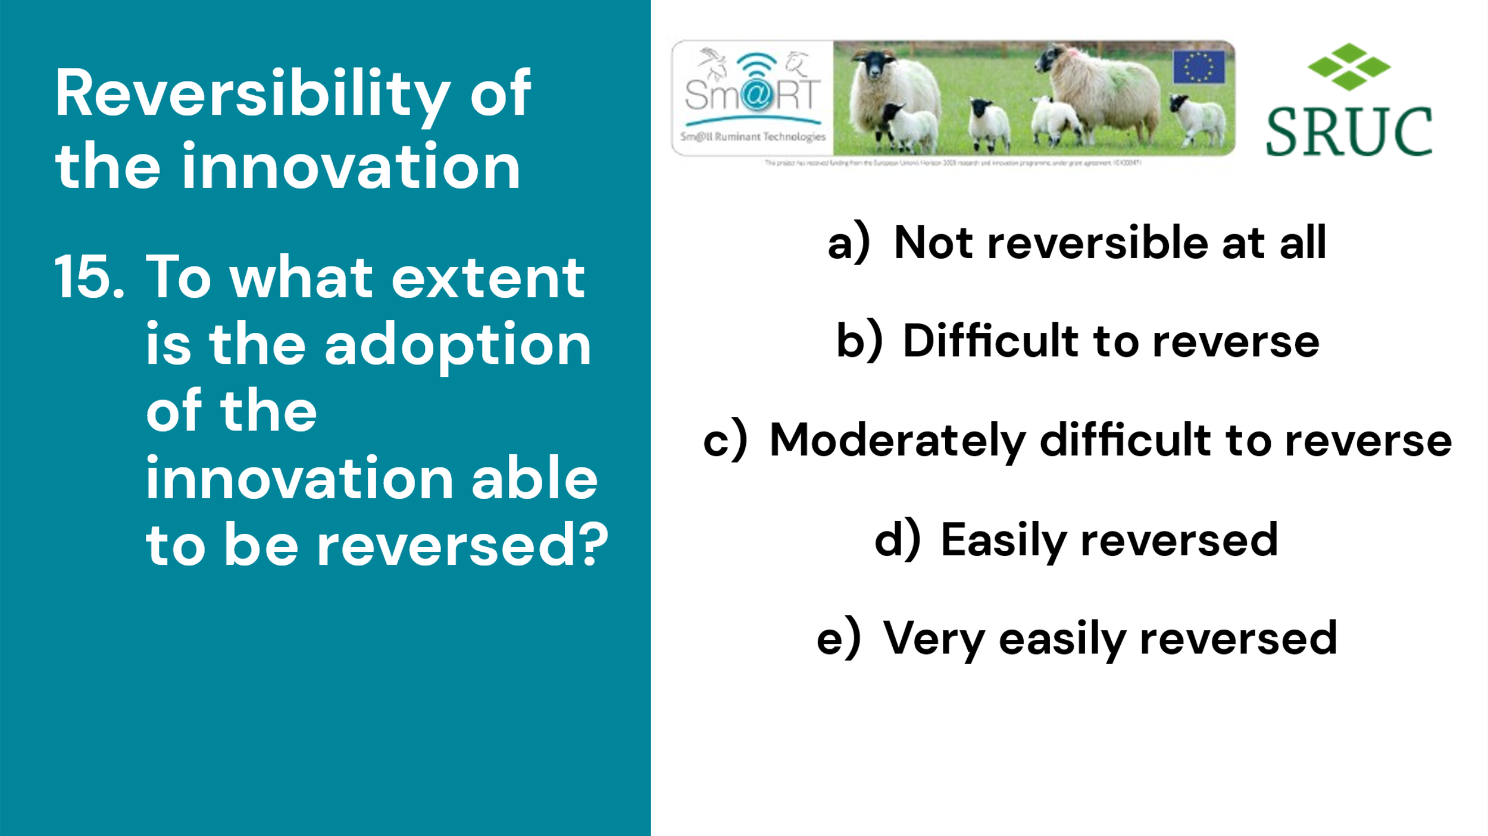
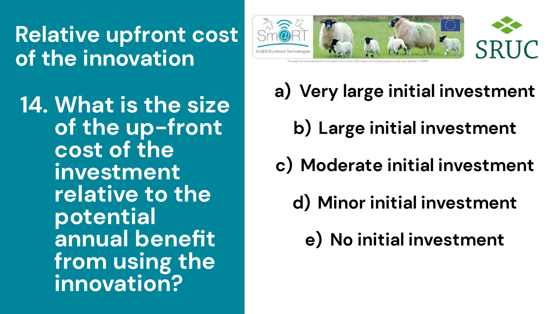
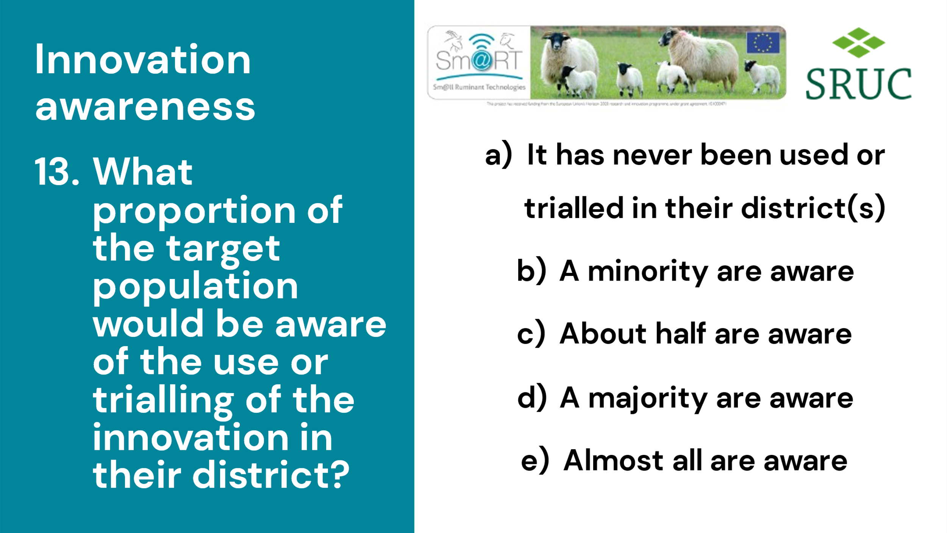
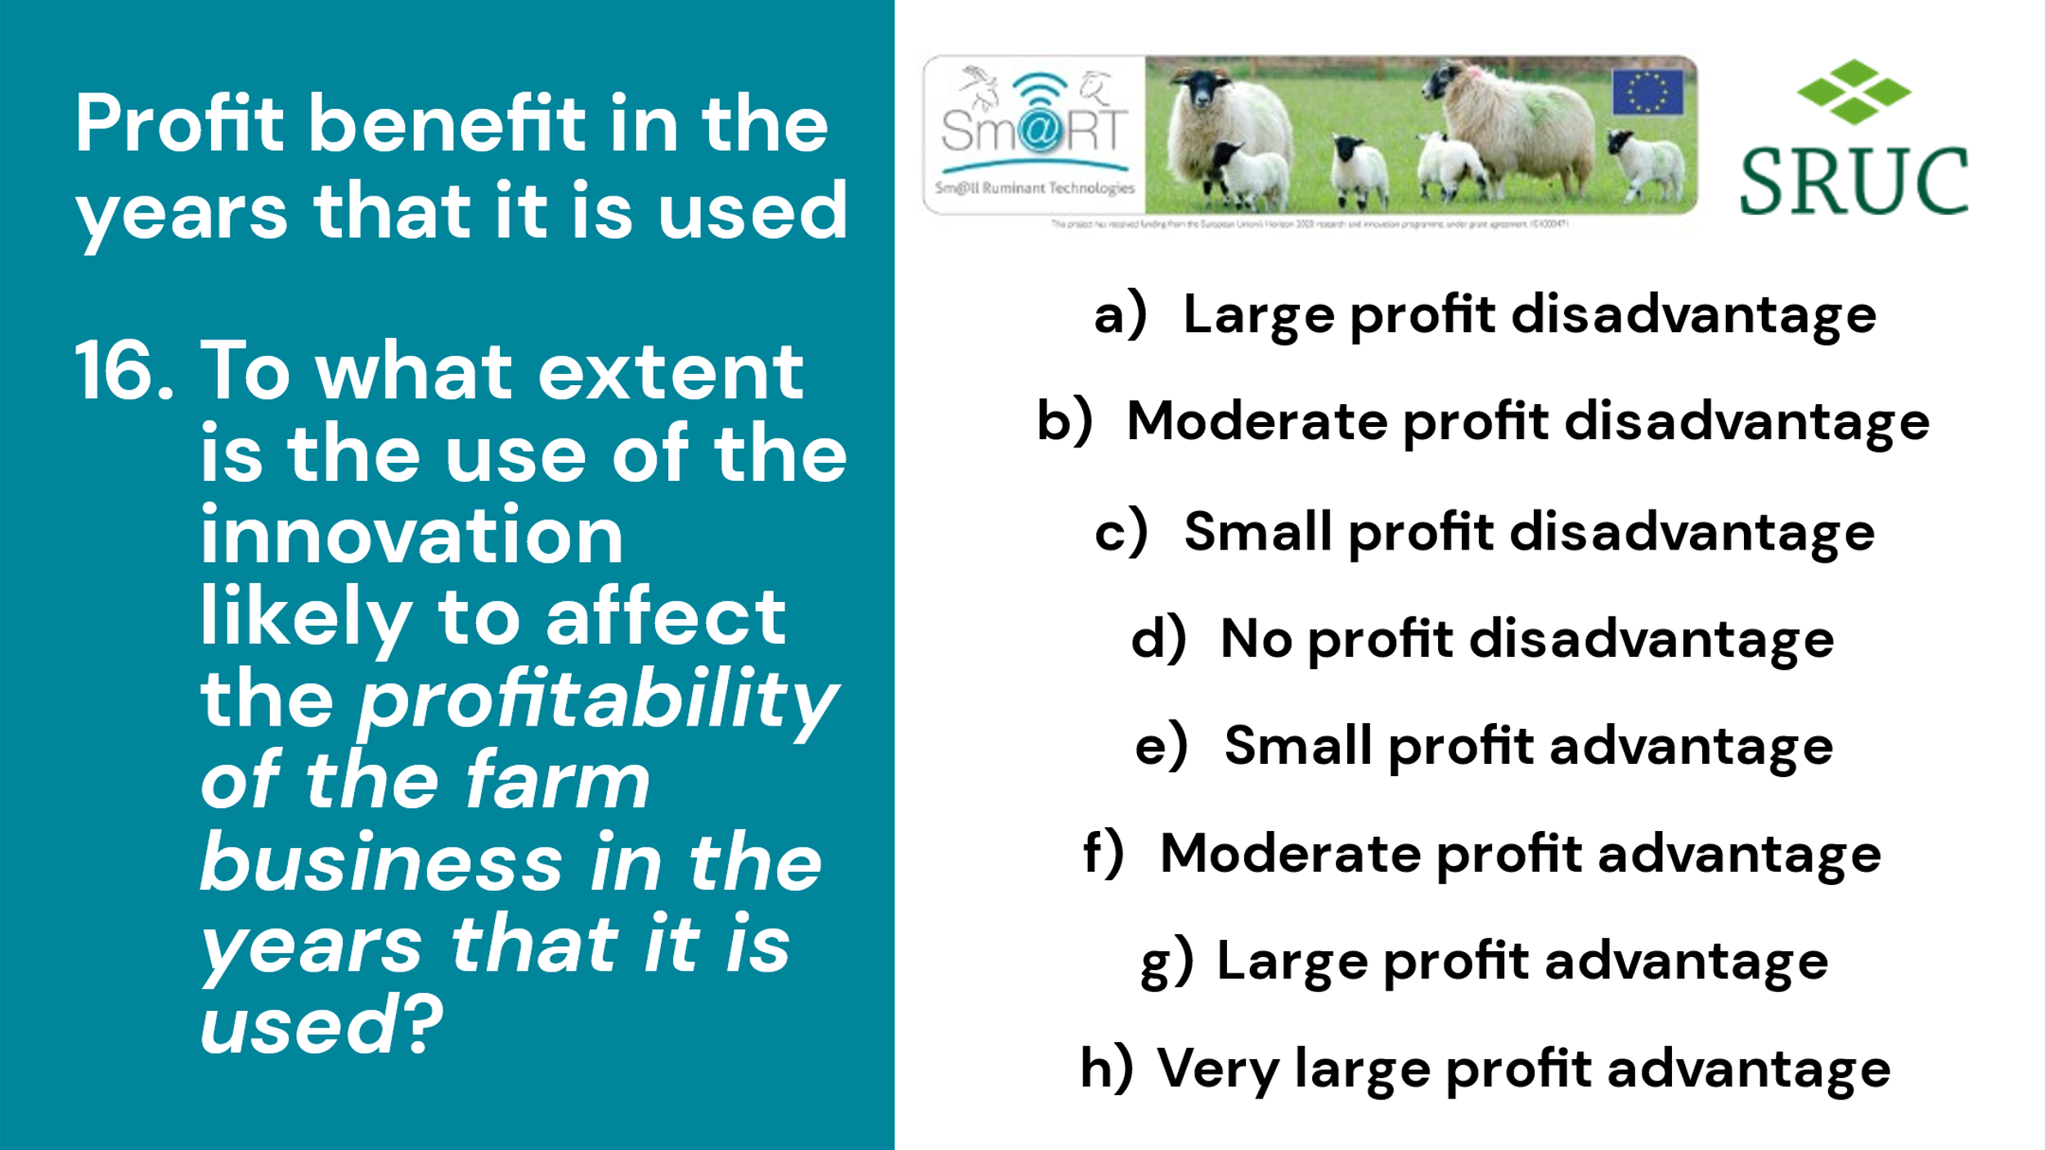

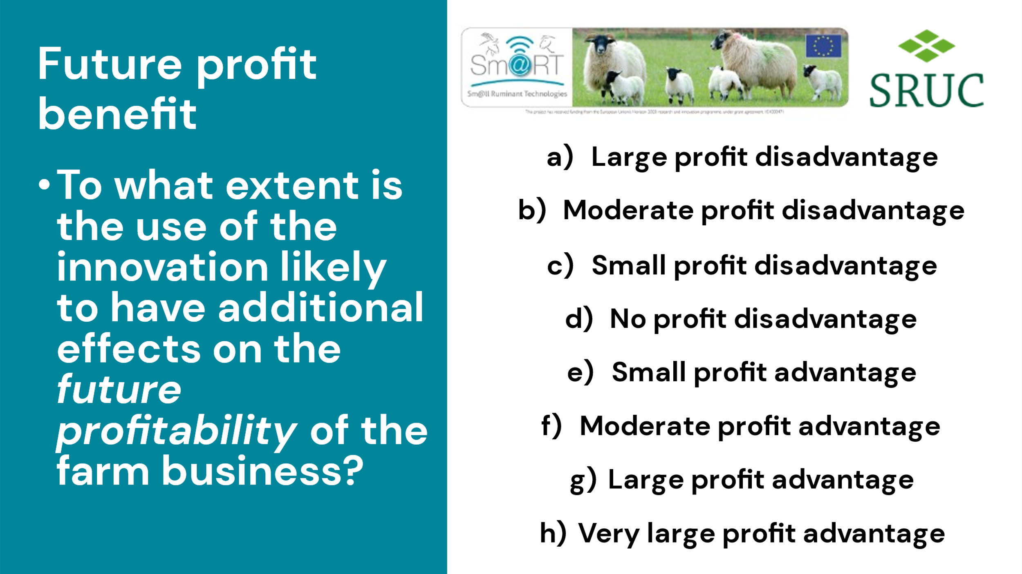

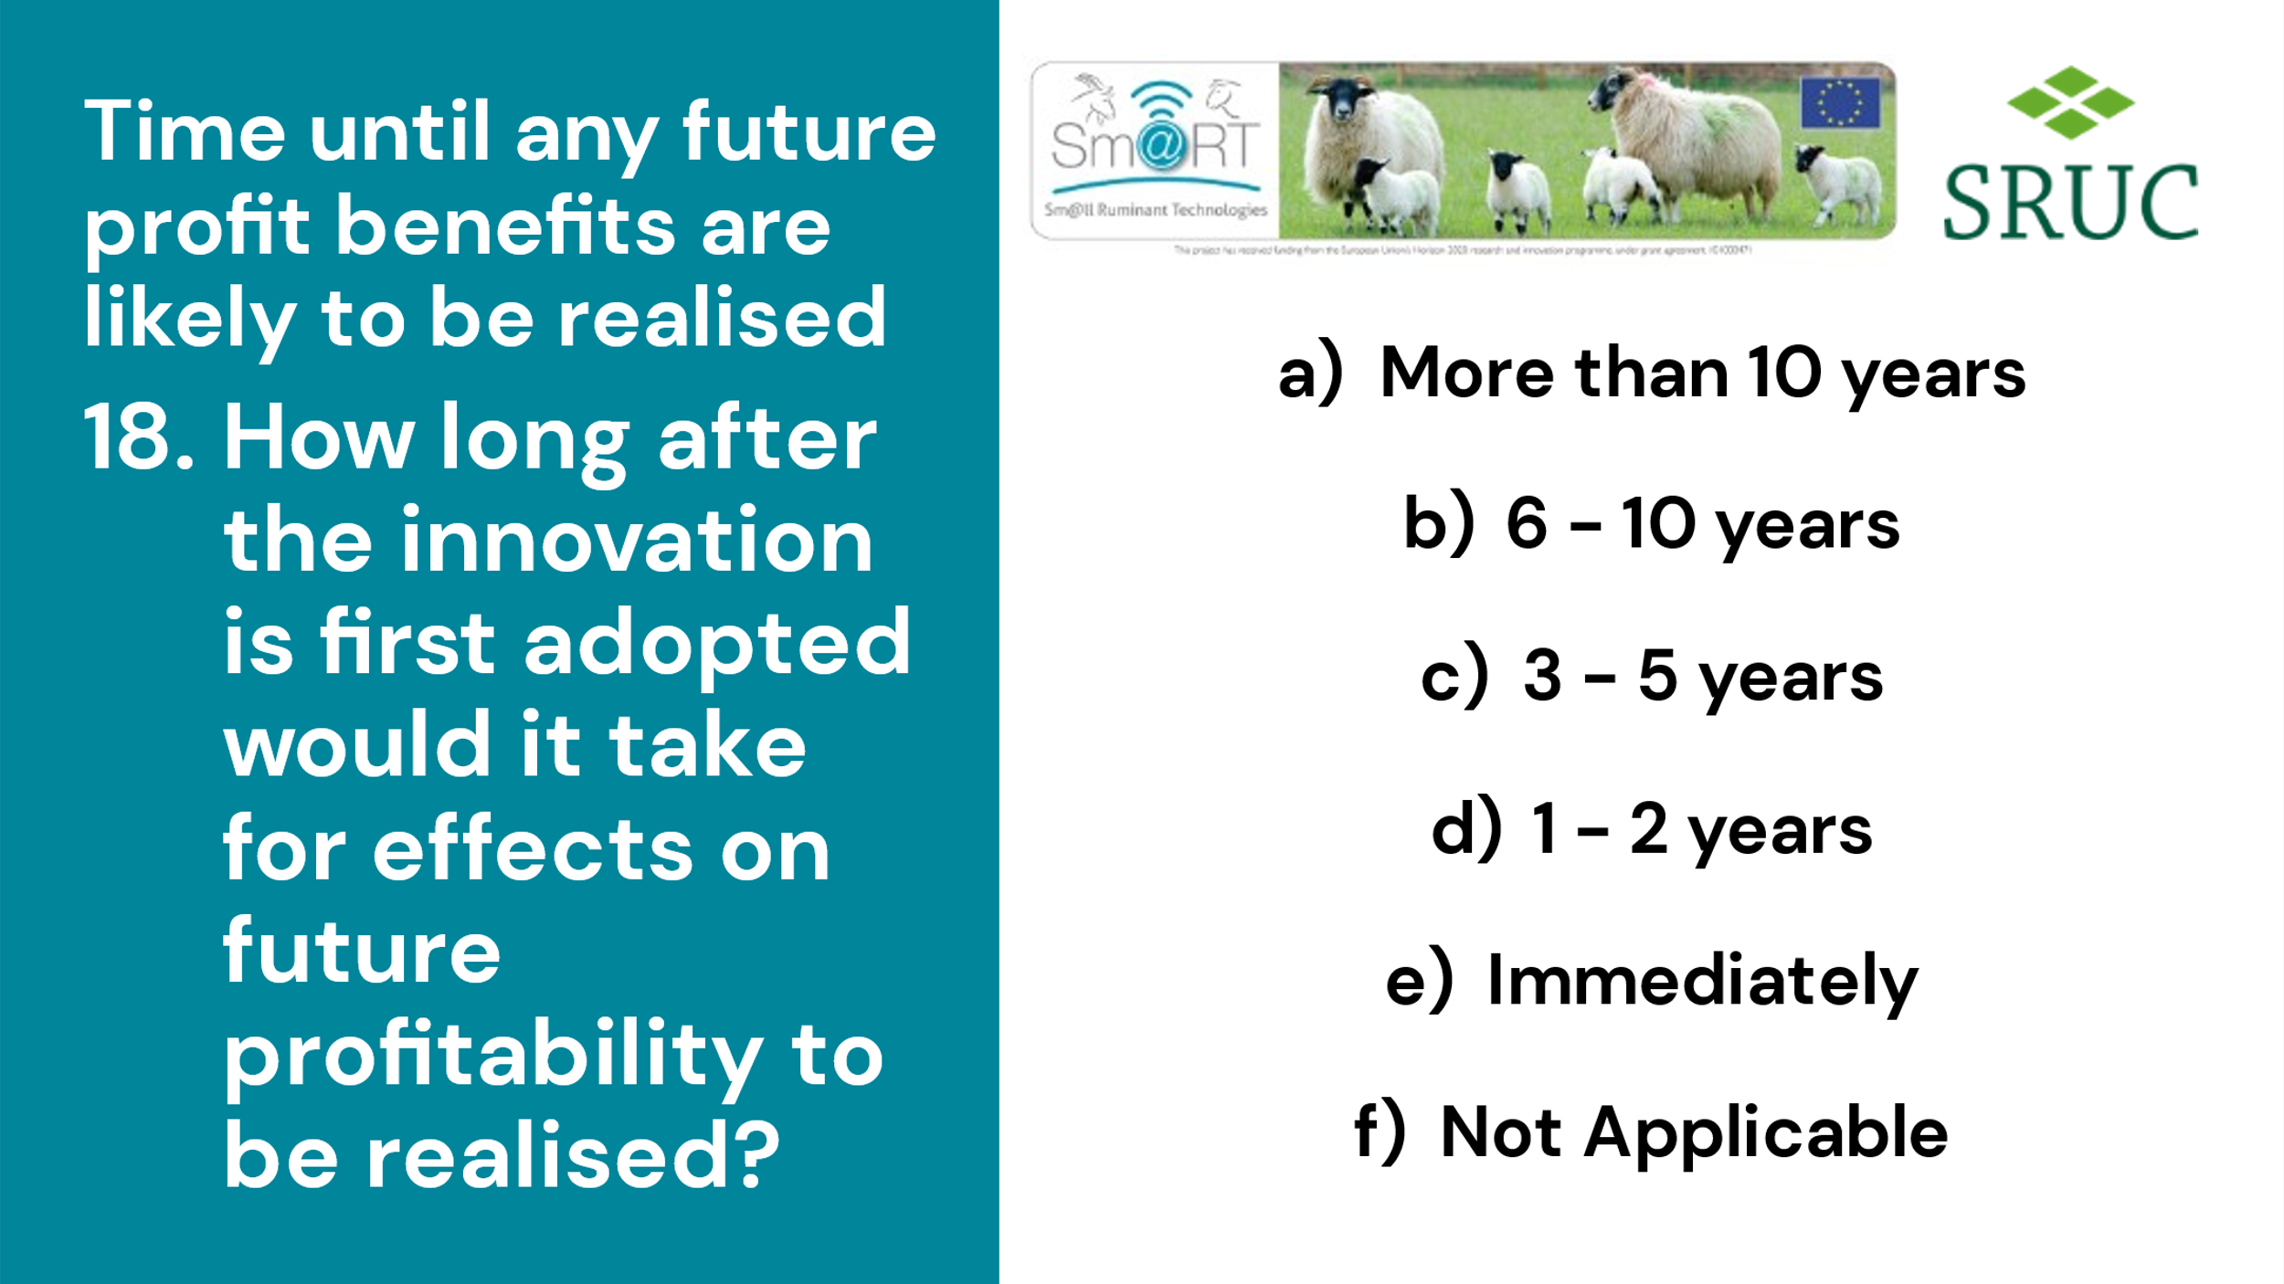
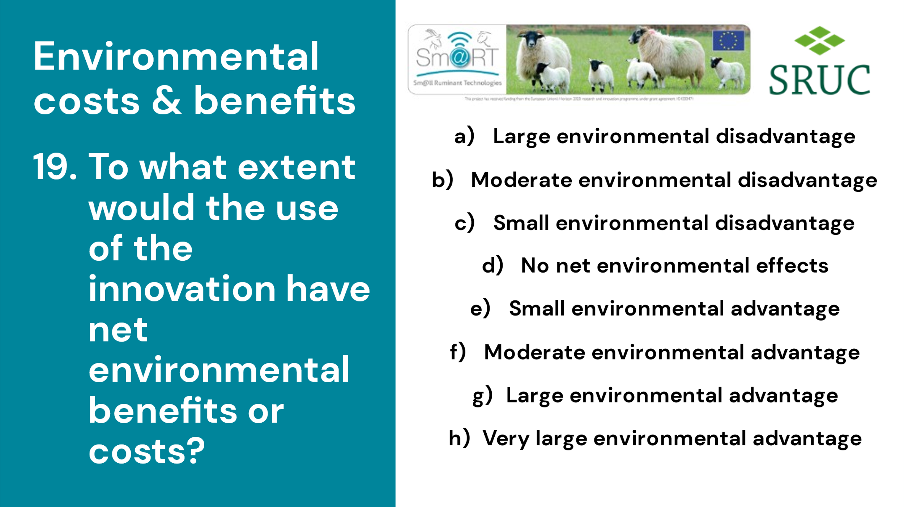
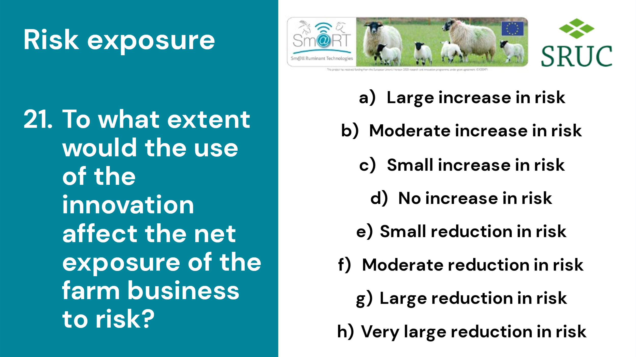
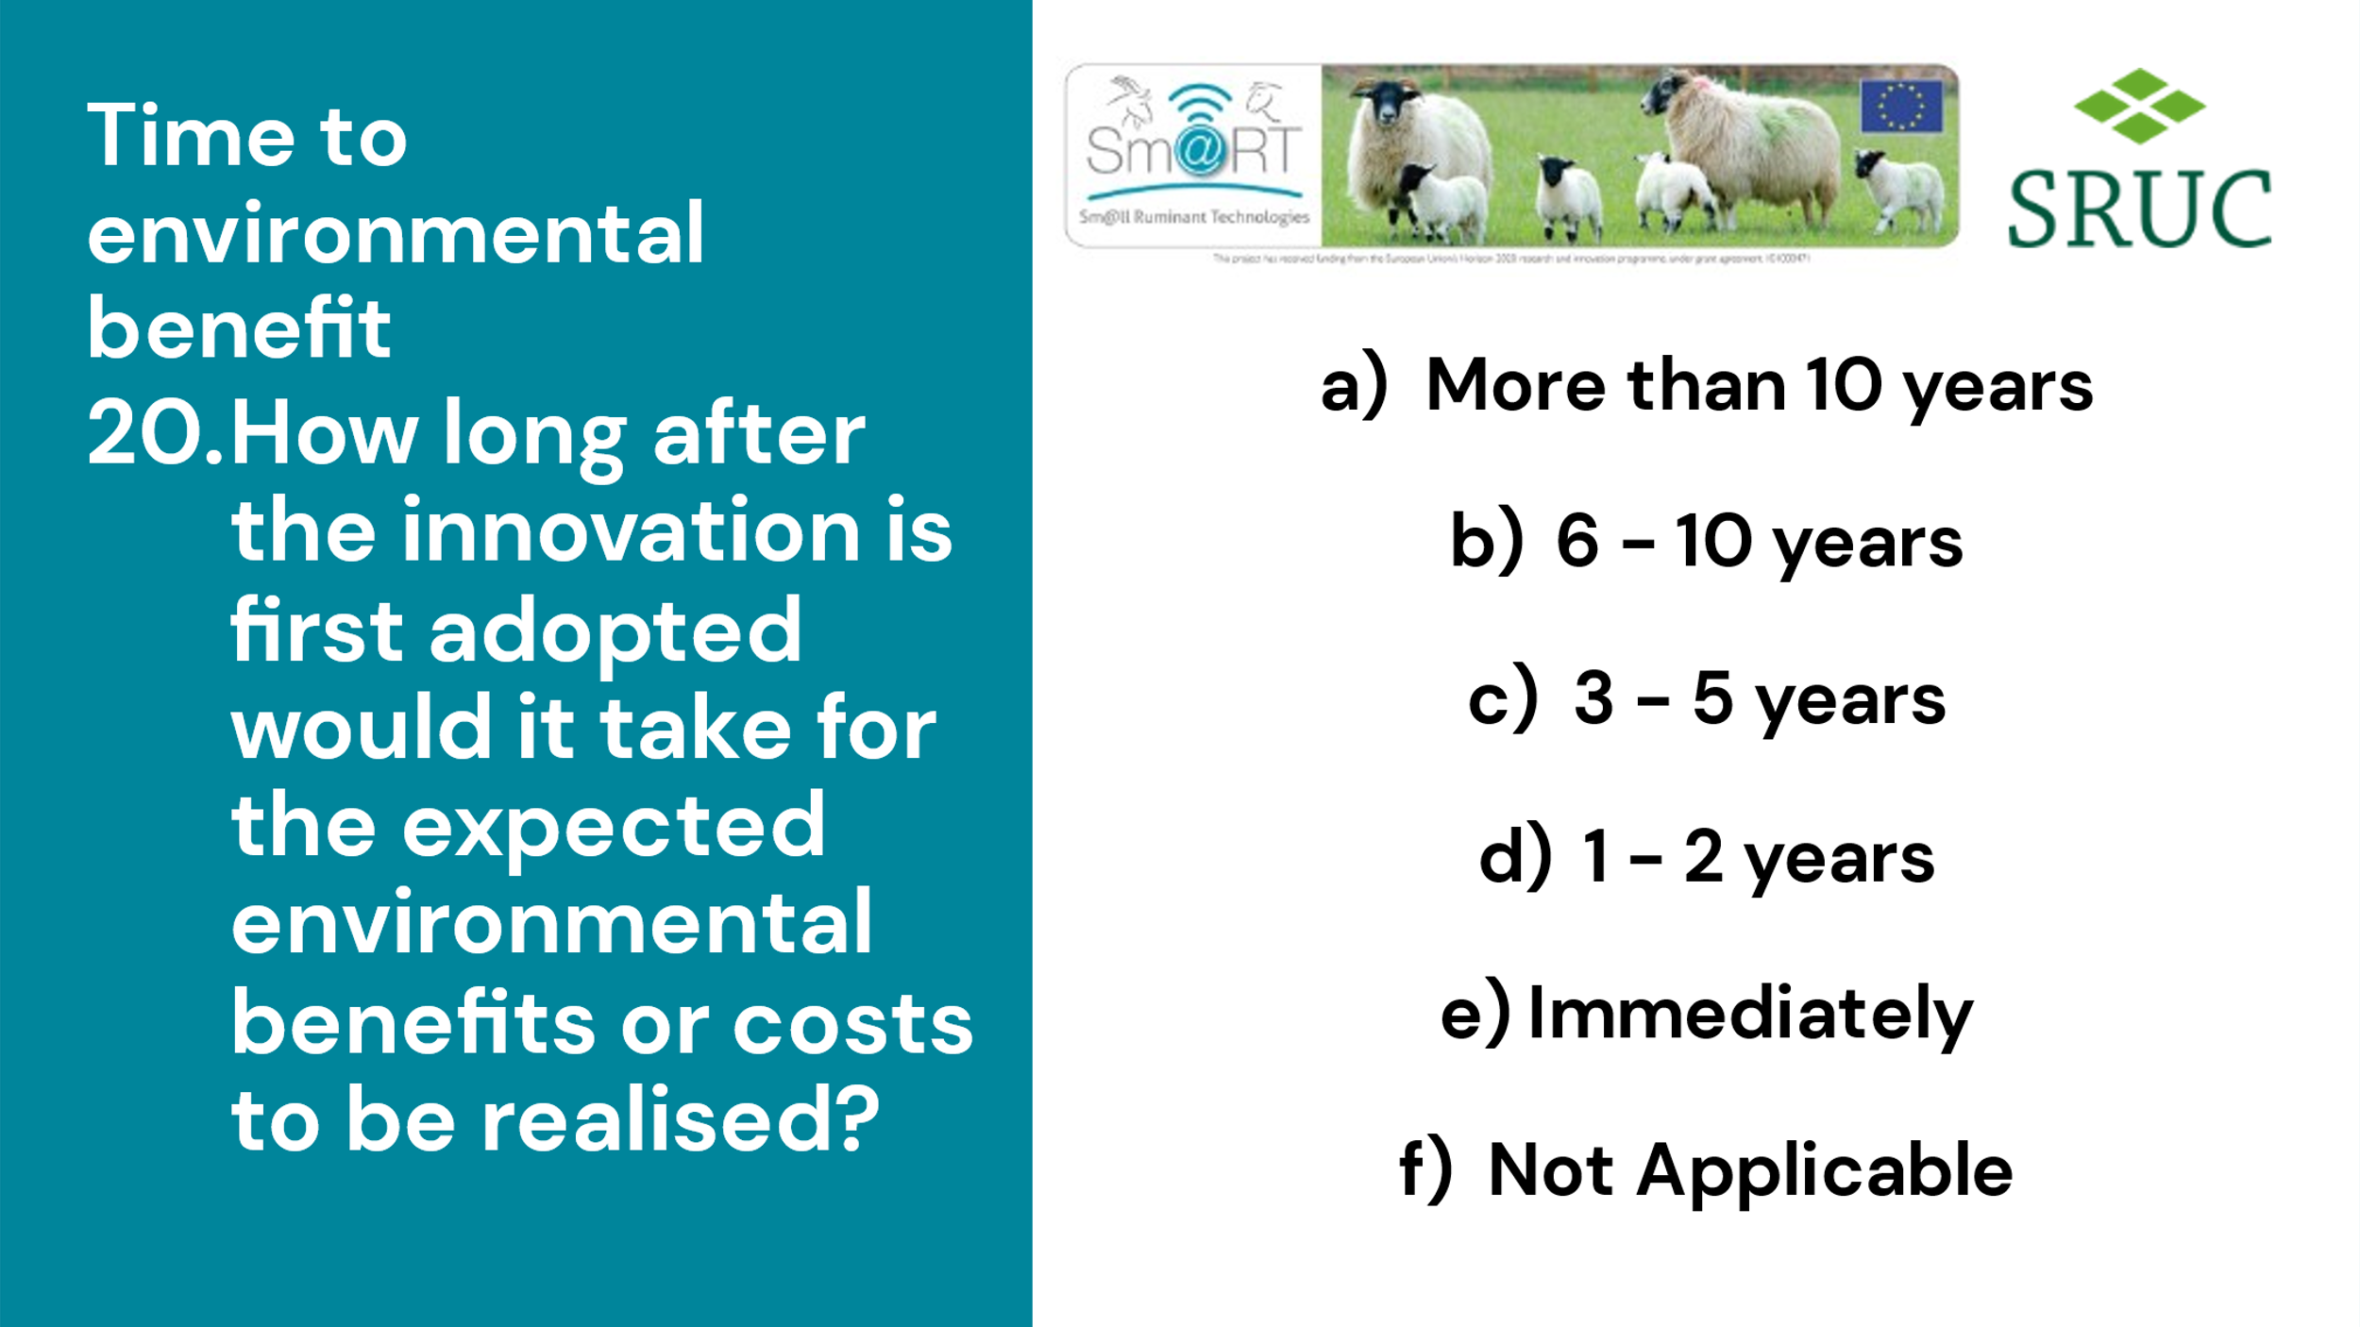
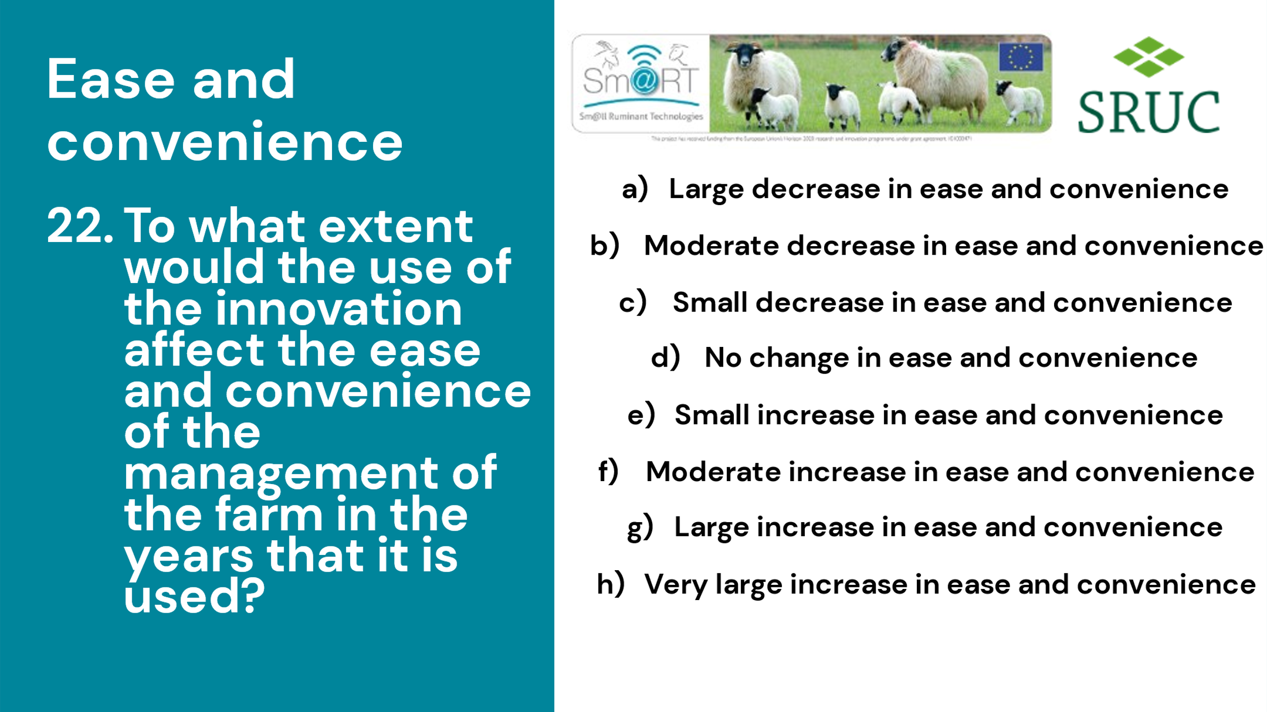

Annex 2- Sign in sheets
