Report of the 4th transnational workshop
Oppdal, Norway
12-15 June 2023
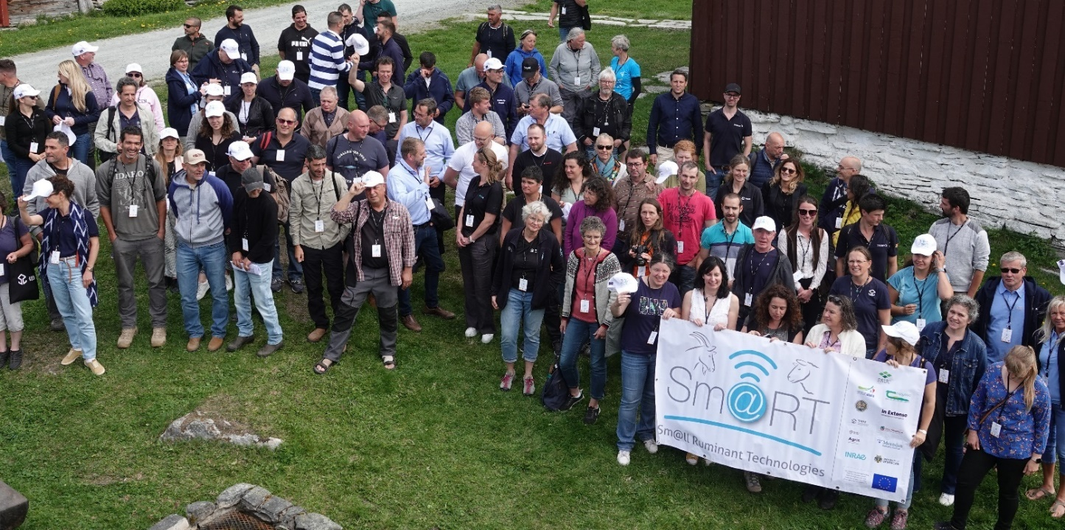
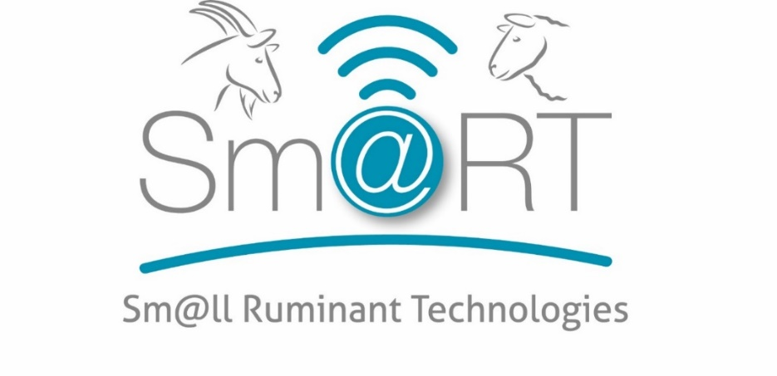

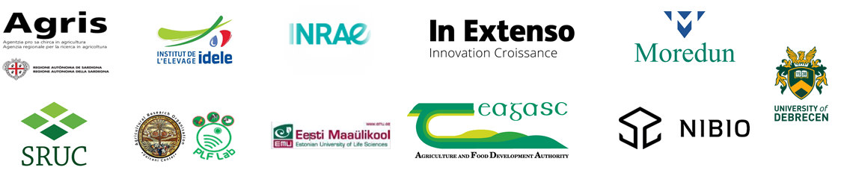

Objectives

The objectives for the fourth transnational workshop were (TNWS 4):
- To present Sm@RT project progress
- To encourage exchanges between the partners’ countries small ruminant sectors
- To meet face to face and create links and cross-fertilisation
- To present Norwegian technologies solutions and discuss needs and barriers to uptake
- To visit Norwegian sheep and goat farms and showcase Norwegian innovative solutions

ORGANISATION AND Attendees

The fourth transnational workshop was the second face to face international meeting. It took place in Oppdal in Norway, on 12-15 June 2023. The agenda of the meeting is detailed in the annex 1.
A total of 105 people participated to this workshop (50 farmers, 16 researchers and 39 consultants)

Monday 12th June 2023

Arrival of delegations

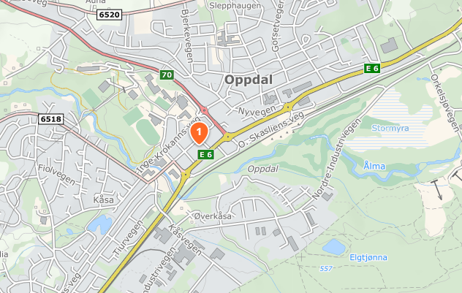
- All delegations arrived at Skifer Hotel in Oppdal. Joint dinner in the hotel restaurant for the delegations arriving in time.

Tuesday 13th June – Workshop at Bortistu in Storlidalen
The first day was dedicated to workshop sessions and presentations by industry.
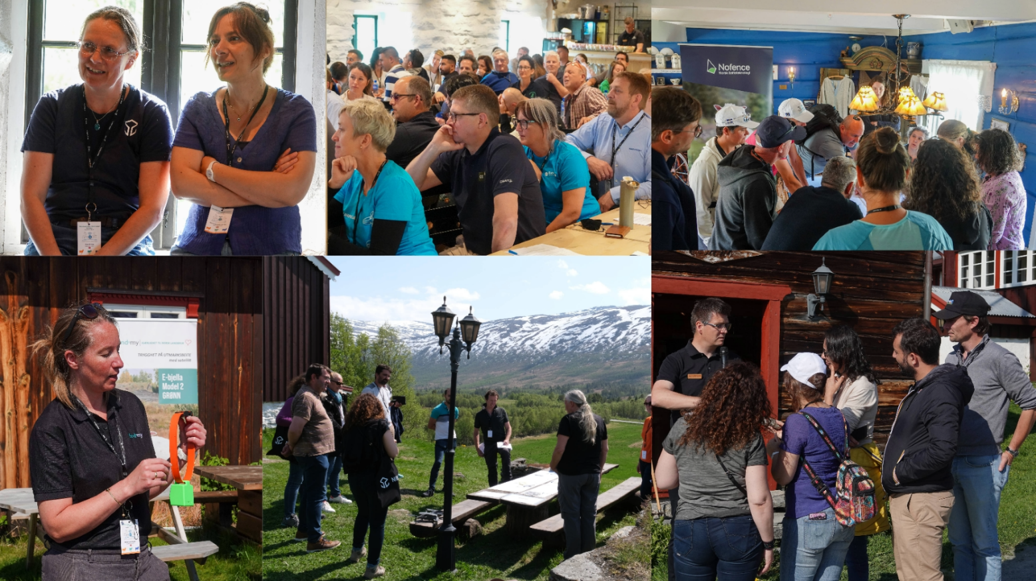
We started with a guided bus trip to Storlidalen, a 40-minute drive from our hotel in Oppdal.

After a short welcome by Lise Grøva (NIBIO – hosting partner) and Claire Morgan-Davies (SRUC – project coordinator), Lise Grøva introduced the Norwegian agricultural sector and the small ruminant sector, followed by a presentation of the agricultural sector in Oppdal by agricultural officer Gro Aalbu. This was followed by a presentation of the small ruminant sectors in each of the delegate countries: Estonia, Hungary, Israel, France, Italy, UK and Ireland, with opportunities for questions.
After a coffee break, each of the participating technology companies had a 10-minute pitch about the technology solution they were bringing:
- Camera surveillance, fire detection and sensor technology, Kjell Jonny Haugan and Stein Magnus Jensen, Elotec
- GPS-tracking system, Marit Solem Mjøen, Findmy
- GPS-tracking system, Nicolay Jansen, Telespor
- Smart eartags and animal tracking, v/Jan Ivar Sanden, RealtimeID
- Virtual fence, v/Magnus Gabrielsen, Nofence
- Sheep data recording system, Marit L. Lystad, Sauekontrollen and Agnete L. Aunsmo, Nortura
- RFID and ID-readerstick v/ Bjørn Ligård, OSID
In addition, Pierre-Guillaume Grisot (IDELE, France) and one of his French farmers presented the EuroSheep project, another EU funded thematic network. Lise Grøva and Oddbjørn Kaasa also presented new knowledge opportunities from GPS tracking data from sheep and the Norwegian Sheep Recording System (Sauekontrollen).

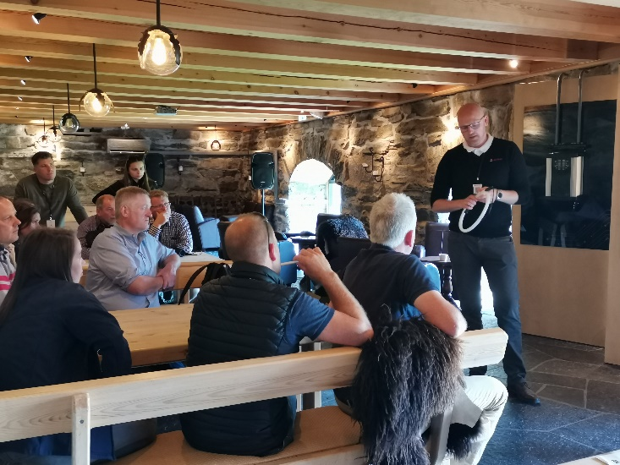
After lunch the technology companies, Pierre-Guillaume for Eurosheep and Norwegian farmers went to their stands, and welcomed groups of participants for sharing experiences, asking questions, and discussing possibilities and challenges related to their technology solutions. The groups (divided by country and with a translator in each group) visited all the stands, moving to the next post every 20 minutes. There was a lot of engaged conversation going on all around the yard! There were also feedback sheets on each stand, for delegates to record their thoughts and ideas.
This exchange of ideas and thoughts proved to be very useful, not only for the farmers and advisors, but also for the technology companies. The workshop was also a nice way to break the ice and start to get to know each other.

The afternoon ended with a visit to the farm museum, a cultural history guided walk and a nice dinner, where the delegates continued their discussions.

Wednesday 14th June- sheep farm visits
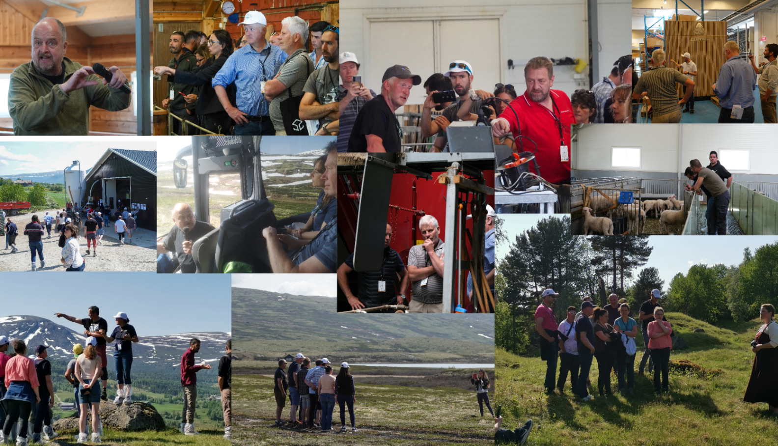
On the second day the participants were split in two groups; both conducted the same program in different orders. We visited three sheep farms in Oppdal, a technology company and made quick guided trip to the summer grazing areas in the mountains (the detailed farm information is found in annex 2).

Usti gard – meat sheep farm run by Nils Petter Hårstad and son

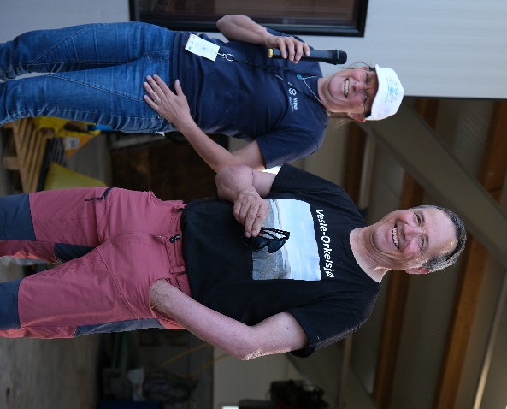
Usti Gard is a meat sheep farm with 300 Norwegian White breeding ewes, located not far from Oppdal village.
Nils Petter Hårstad presented the main facts about the farm, and the technology solutions used in his farm management.
Technologies presented were:
- automatic feeding system (with feed mixer and feed belt)
- Norwegian Sheep Recording System and RFID reader stick
- Elotec steerable camera
- GEA milk feeder
In addition to the arable land, Usti Gard has large areas of cultivated pastures for spring grazing, and the delegates got to take a stroll and say hello to the sheep out in the field.
The visit at Usti Gard ended with coffee and birthday cake, as it so happened that the farmer had a birthday that day!

Kvalsjord gard meat sheep farm run by Bernt Inge Hoel and Tove Godtland

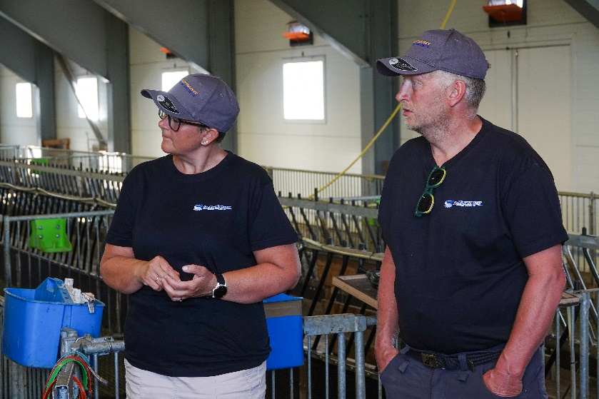
At Kvalsjord farm there are 334 breeding ewes, mostly Norwegian White sheep, but also some Blæset sheep.
Kvalsjord farm is one of the neighbours to Usti Gard, and the farmers have some collaboration.
After an introduction about the main facts about the farm the technology solutions were presented:
- Norwegian Sheep Recording System (Sauekontrollen) and RFID reader stick
- Elotec Steerable Camera
- GEA Milk Feeder
- Weight scale and sorting

Lunch was served back at the hotel in Oppdal.

Oppisto Mjøen -Meat sheep farm run by Eivind and Torhild Mjøen

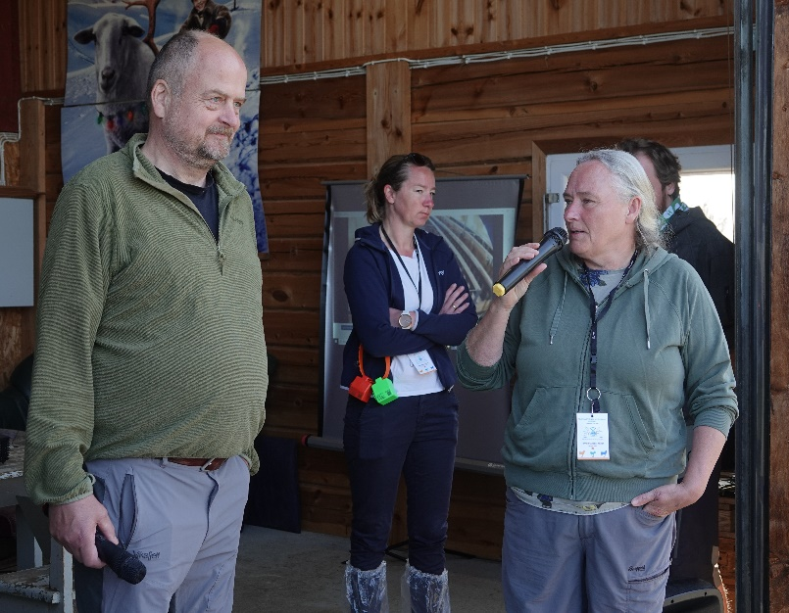
Eivind and Torhild Mjøen have 250 breeding ewes, mostly Norwegian White and some Spæl (an old Norwegian breed).
Eivind and Torhild and their son Bernt Såstad Mjøen introduced the main facts about the farm, followed by a presentation/demonstration of the technology solutions they use:
- Norwegian Sheep Recording System and RFID reader stick
- DeLaval camera
- GPS-Tracking: Telespor and Findmy
- Drone
The Marit Solem Mjøen, CEO of Findmy, was present at the farm to answer questions, and the son demonstrated the use of the drone.

ELOTEC AS – Tech company
Coffee was served at Elotec, and we were given a tour of the company.
Elotec started as a company making fire alarm systems for farmhouses. They now also sell sensor technology solutions and camera systems, amongst other things.

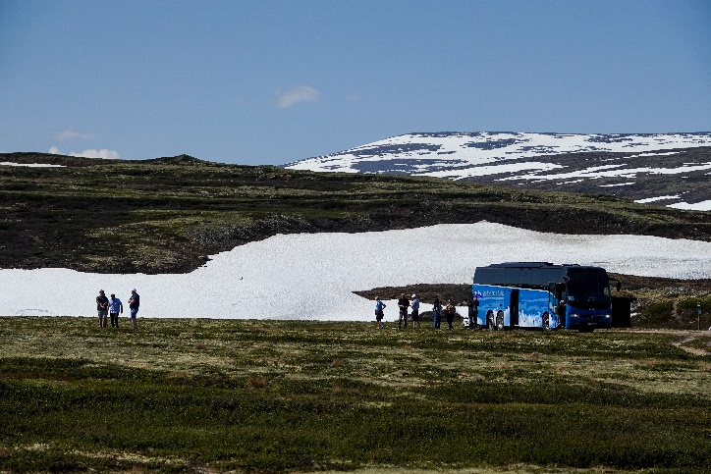
Mountain grazing area
In Norwegian sheep farming, grazing unfenced mountain rangelands is important. Many farms have access to vast areas of rangelands (often commons). The animals are brought there as soon as spring arrives and stay all summer. The farmers are organized in mountain farm grazing groups, where all farms with grazing rights in the area are represented. We took a trip up to Eivind and Torhild Mjøens grazing area at Orkelsjøen, with Eivind as a guide on the bus. The participants got a good idea of the vastness of the mountains and the challenges a sheep farmer can meet there.

Before the festive dinner in the evening, we had time for cultural input, and visited Oppdal’s Viking burial ground.

Viking Graves
The day was concluded with a “one woman show” at the largest Viking burial ground in Norway: a Viking lady who woke up from the dead a few years ago humorously informed us about the Viking Age in Oppdal.

Evaluating
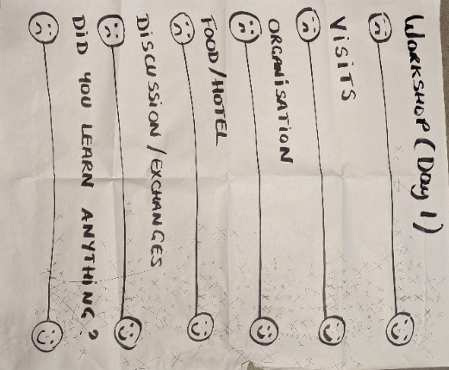
At the festive dinner the participants were asked to give feedback on the two first days of the TNWS. The feedback poster shows that participants were pleased with the program.

Thursday 15th june – goat farm visits
For the third and last day, the group was also split in two. This day was dedicated to two goat farm visits.
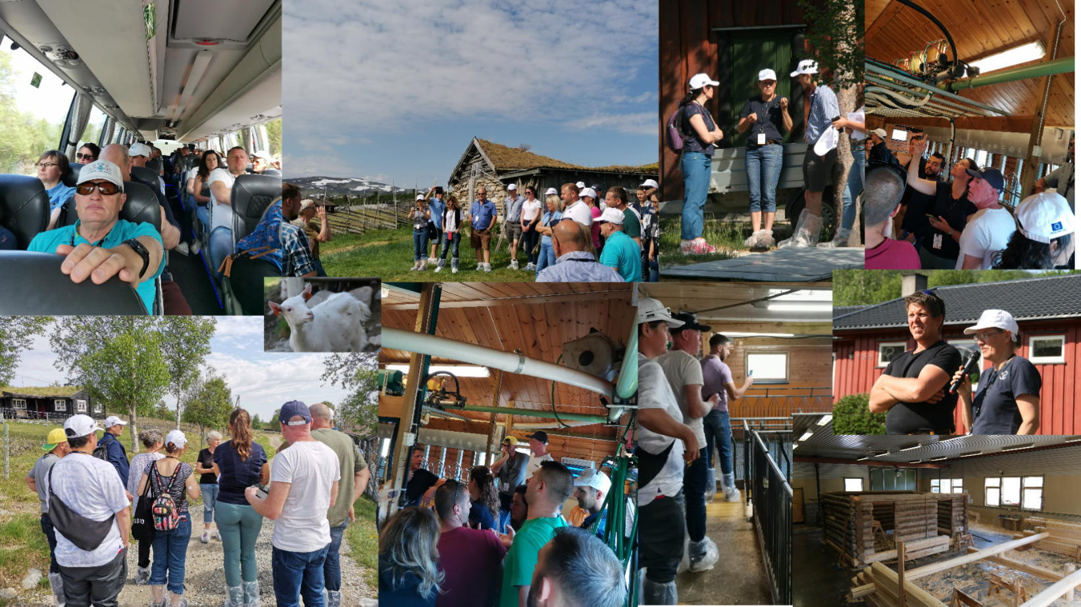
Goat farming in Norway is a small industry with a wide geographical spread, and we inevitably had to spend some time on the bus to get from A to B.

Elgvasslien gård, Folldal dairy goat farm run by Bjørnar and Siw Elgvasslien

Bjørnar and Siw have 95 dairy goats of the Norwegian breed.
Bjørnar and Siw presented the main facts about their farm, and the technologies they use:
- Automatic concentrate feeder
- GEA milking machines
- Milk feeder for goat kids
Besides being a goat dairy farmer Bjørnar is a carpenter building traditional Norwegian log houses, and the participants also got to have a look in his carpentry workshop.

Øverdalssetra, Sollia

common summer farm of Sollia Prestegård and Tangen Gård
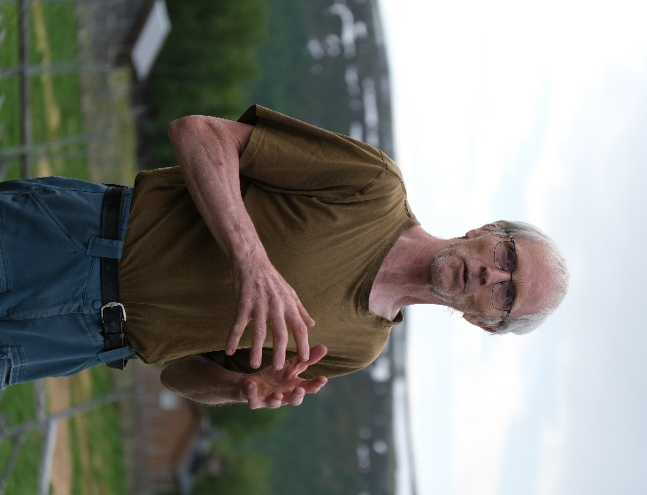
120 goats and 30 kids from the two farms spend the summer at Øverdalssetra, grazing the cultural landscape around the summer farm. Farmers are Hans Bondal and Ellen Marie Tangen (Sollia Prestegård) and Rasmus Kristensen and Iben Wermuth Andresen (Tangen Gård).
Hans introduced the farms’ management and the year’s activities. This is a low-tech summer farm. The only technology used is:
- Strangko milking machines
Milk from the two farms is curdled in their own cheese factory, and there is a small café at the summer farm – where coffee and cake were served.

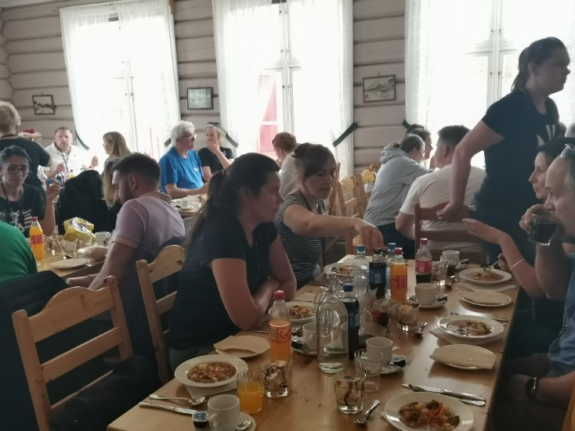
After the goat farm visits the last lunch was served at Folldal Gruver.
The Transnational Workshop ended officially after lunch. The coordinator and the delegations thanked the Norwegian hosts for the very interesting workshop and thought-provoking visits.
Some of the delegations travelled home in the afternoon and some in the evening, and there was a last dinner at the hotel in Oppdal for the delegations still present.

Annexes

Annex 1: Detailed program

Annex 2: Farm descriptions og farms presented in Workshop Day 1 and Farm Visits Day 2 and 3

Annex 3: Attendance sheets

