### NWS 3 NORWAY – feedback on innovations

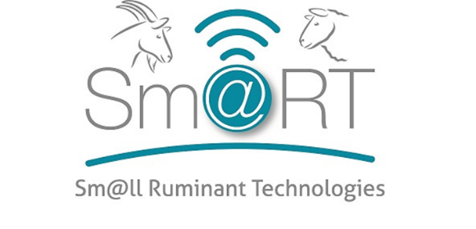

### Date and place of the NWS 3:

**NWS3_goat:** 1st September 2022, Meløya, summerfarm of Storsteigen agricultural college, Norway.

### Present:

**Number of participants 33:**

Lise Grøva, researcher NIBIO

Anne DeBoer, researcher NIBIO

And 7 goat farmers, 20 students in farmer training, 4 stakeholders

### Organisation:

NIBIO (Lise Grøva and Anne DeBoer) in collaboration with Storsteigen agricultural college and TINE (dairy cooperation) hosted the workshop at the summer farm of the Digifarm of Storsteigen. The weather was lovely and people enjoyed both the talks and tasting of local food with various local goat and sheep produce for lunch. A group of last year students at the college were also present to participate to the workshop, and did so with enthusiasm.

Ingar Moldstad, farm manager at Storsteigen welcomed everyone and gave a brief introduction to the goat farming system at the summer farm.

Lise Grøva presented the mastitis project of TINE.

Lise Grøva presented the Sm@RT project and the goat pilot work conducted in the TechCare project.

The workshop was organized with posters on different relevant technologies put up on the walls outside for all to put postit notes indicating:

* Is the tech relevant to you: yes – no
* Why do you need it?
* What can it be used for?

The following techs were discussed:

* Milk tank weight
* GPS
* Virtual fencing
* Behaviour and animal flow
* Other new ideas?

Also, the questionaire sheets were made available. However, the use of these sheets failed as priority of time was to put on writing postit notes discussion tech solutions.

|  |  |  |  |  |
| --- | --- | --- | --- | --- |
| **Tool** | **Main use/ advantage** | **Any other functions?** | **Barriers** | **Any modifications?** |
| **GPS** | Easy to find animals  Interesting to learn/follow grazing patterns  Good control of animals in grazing period  Saves time | Can detect if animals are chased by predators/move un normally | Worry that signals / rays affect health of animals | Prize issue |
| Virtual fence | Less time and money to put up fence  Safer for animals as they don’t get stuck in fences  Better control of animals  Rotational grazing  Ease of gathering animals in autumn  Better attention to animals in grazing season | . Less conflict of interest with others that have activity in rangeland areas  Better use of available pastures  Use of new grazing areas that are difficult to fence | Worry that it will affect health/welfare of animals  To expensive | Price issue |
| Milk tank weigh | Unnecessary cost  Milk is weight when milk truck is collecting milk anyway  Not useful  Doubtfull of the usefulness  Does not detect individual yield | non | Do not find it useful | non |
| Individual behaviour and animal flow | Gives good control of individual animals  Precise feeding of individuals  For individual concentrate feeding  SensHub for cattle could be modified for goats | New knowledge on animal behaviour, welfare and how it affects production. | * Prize * Not relevant for all farmers | * Modify cattle systems i.e. SensHub |
| New ideas | * Combine information from various techs such as Nofence, recording systems, GPS tracking. * New APP: When selling lamb in autumn tracking info can follow the carcass for consumer information. Also, consumer can join gather sheep in autumn | * Awareness to public on small ruminant produce | * Uptake and expenses | * To be invented |

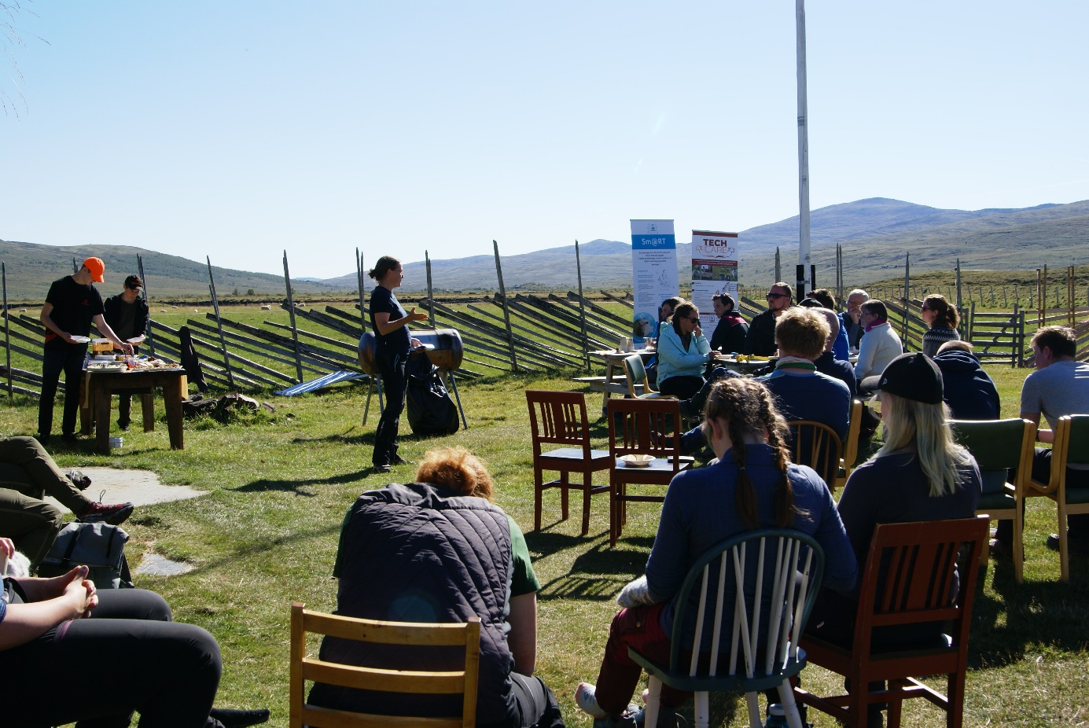

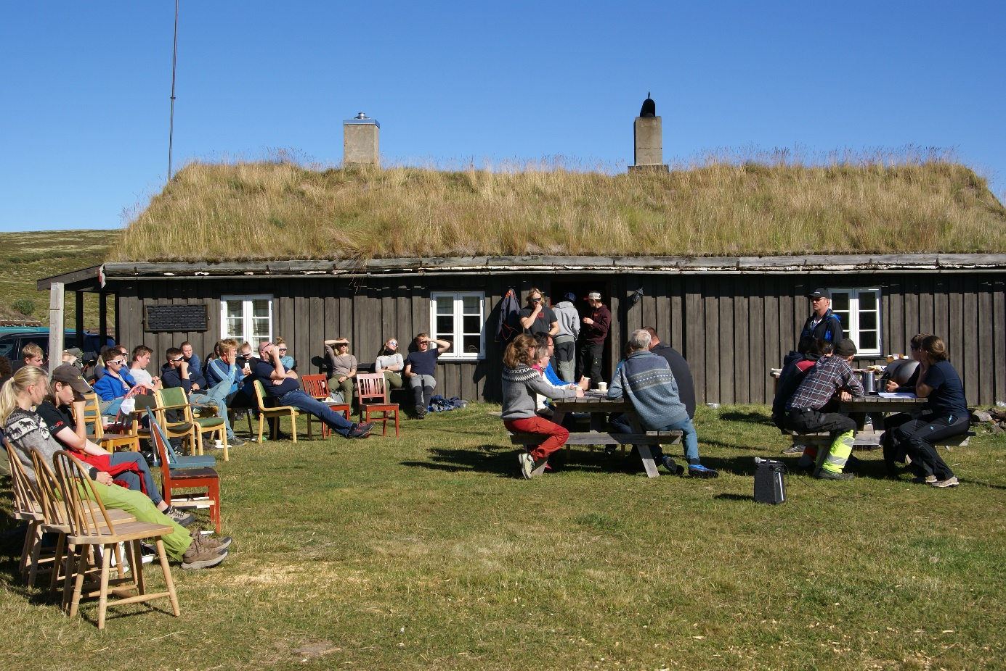**Some pictures from the workshop:**

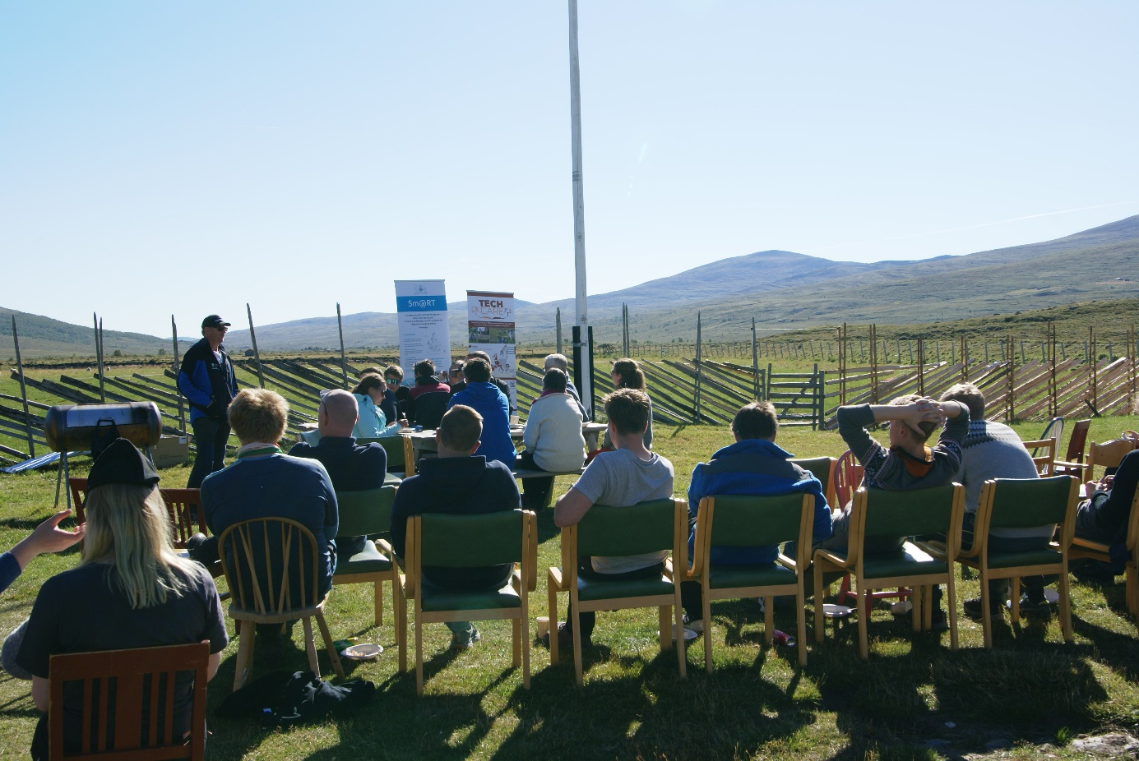

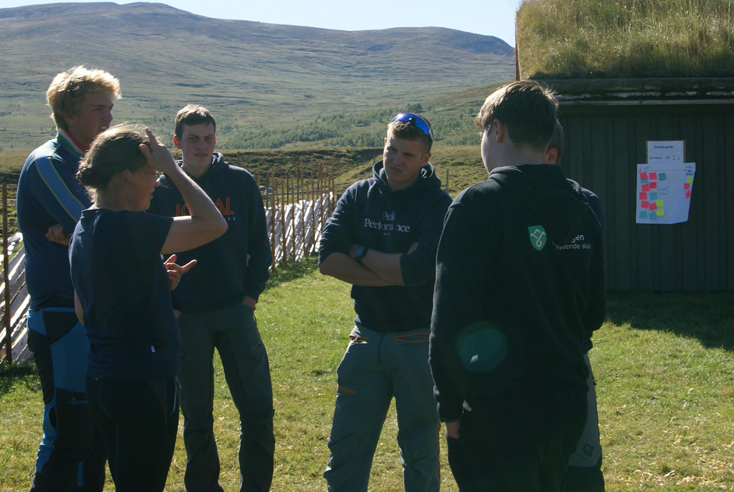

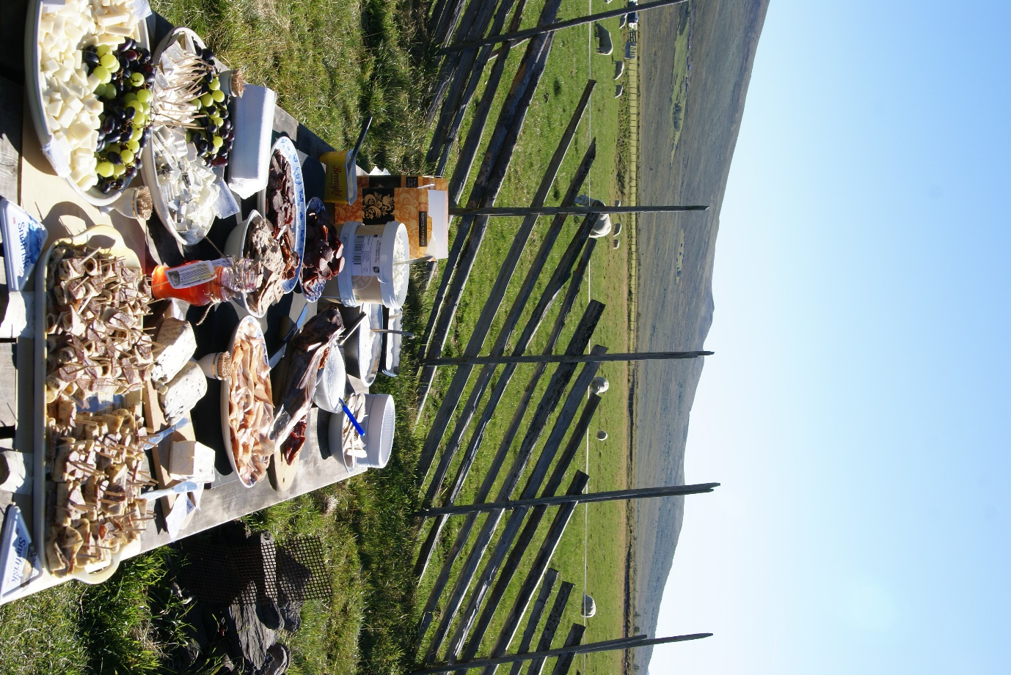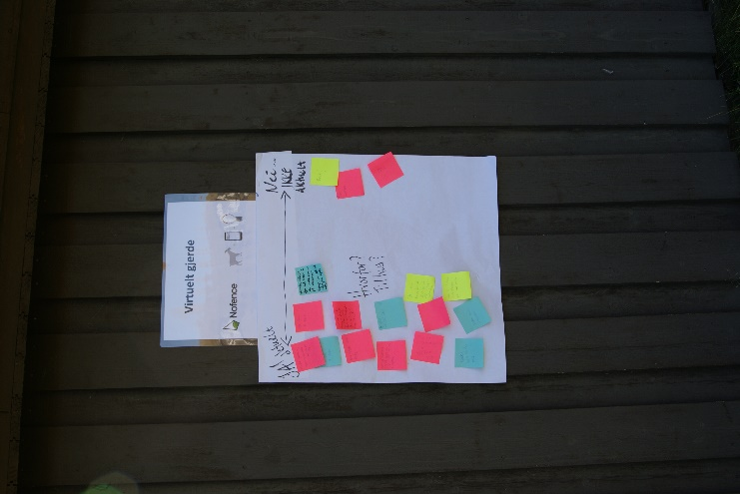

Invitation was sent to all goat farmers in the district by email. Also, invitation was posted on relevant FB-groups:

